‘Managing Transitions’
- List the type and function of the transitions that you observe during the entire school day.
- Identify the strategies that are used by your MST to facilitate these transitions.
- Comment on the success of these strategies in terms of both promoting positive behavior and minimizing the incidence of challenging behavior.
- Make practical suggestions about how these transitions could be modified in order to further promote positive behavior and minimize the incidence of challenging behavior.

 | Type and function of transitions | Strategies used to facilitate transitions | Efficacy of the strategy in terms of promoting positive behavior and minimizing challenging behavior. | Suggestions for further development.
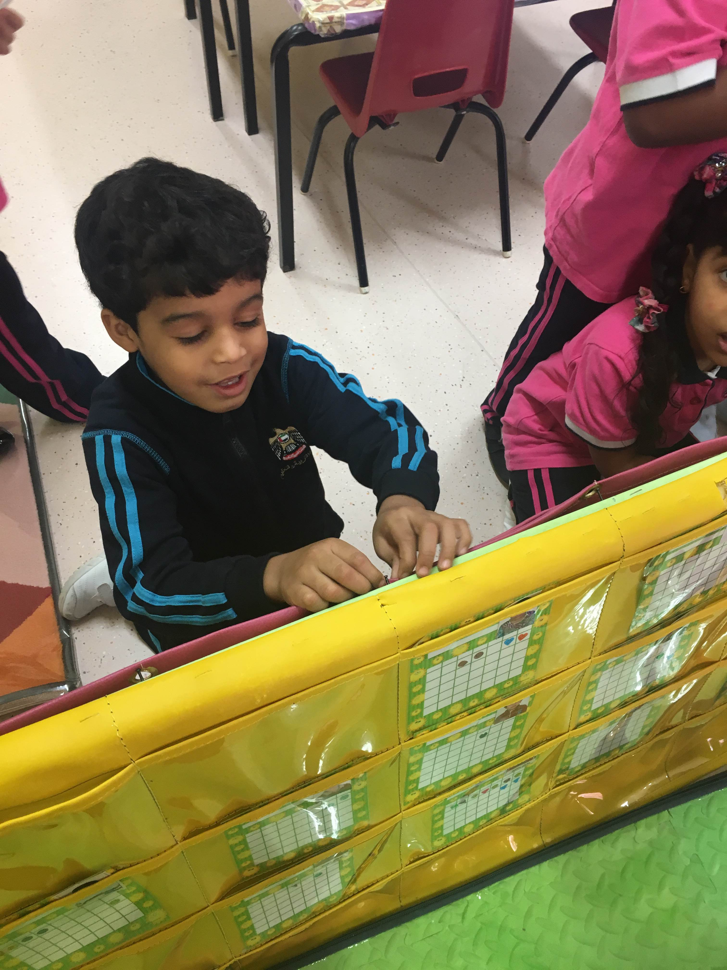  1 | Entering the classroom and putting names in the registration board | In the morning, children come from their homes and enter the classroom. The teacher sometimes doesn’t come early so students do the registration by them selves. First, they put their bags in the bags box and put their other stuff like water and food in the shelves that each student has one with his name and picture on it. There is also a basket with students’ names cards so that each one comes can take his/her card and put it in the registration board. | The teacher is already prepared everything for the students, the bags box, the basket of their names and the shelves that has their names and pictures on it so that students know where to put their stuff and not use each other shelves, and they know that they have to take their names from the basket and put it in the registration board. | It is better if the teacher always come early and before the students, because from my observation students everyday fight on the basket to take their names and put at the top of the registration board. They also push each other beside the bags basket to put their bags first.
2 | 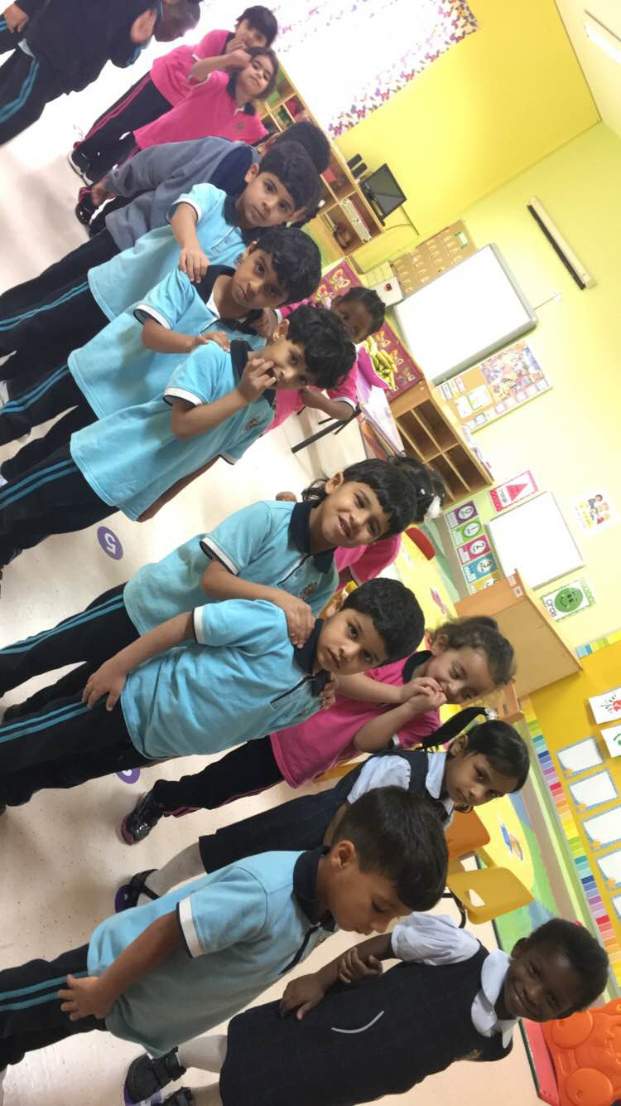  Directing students to line up to go to the toilet/playground.  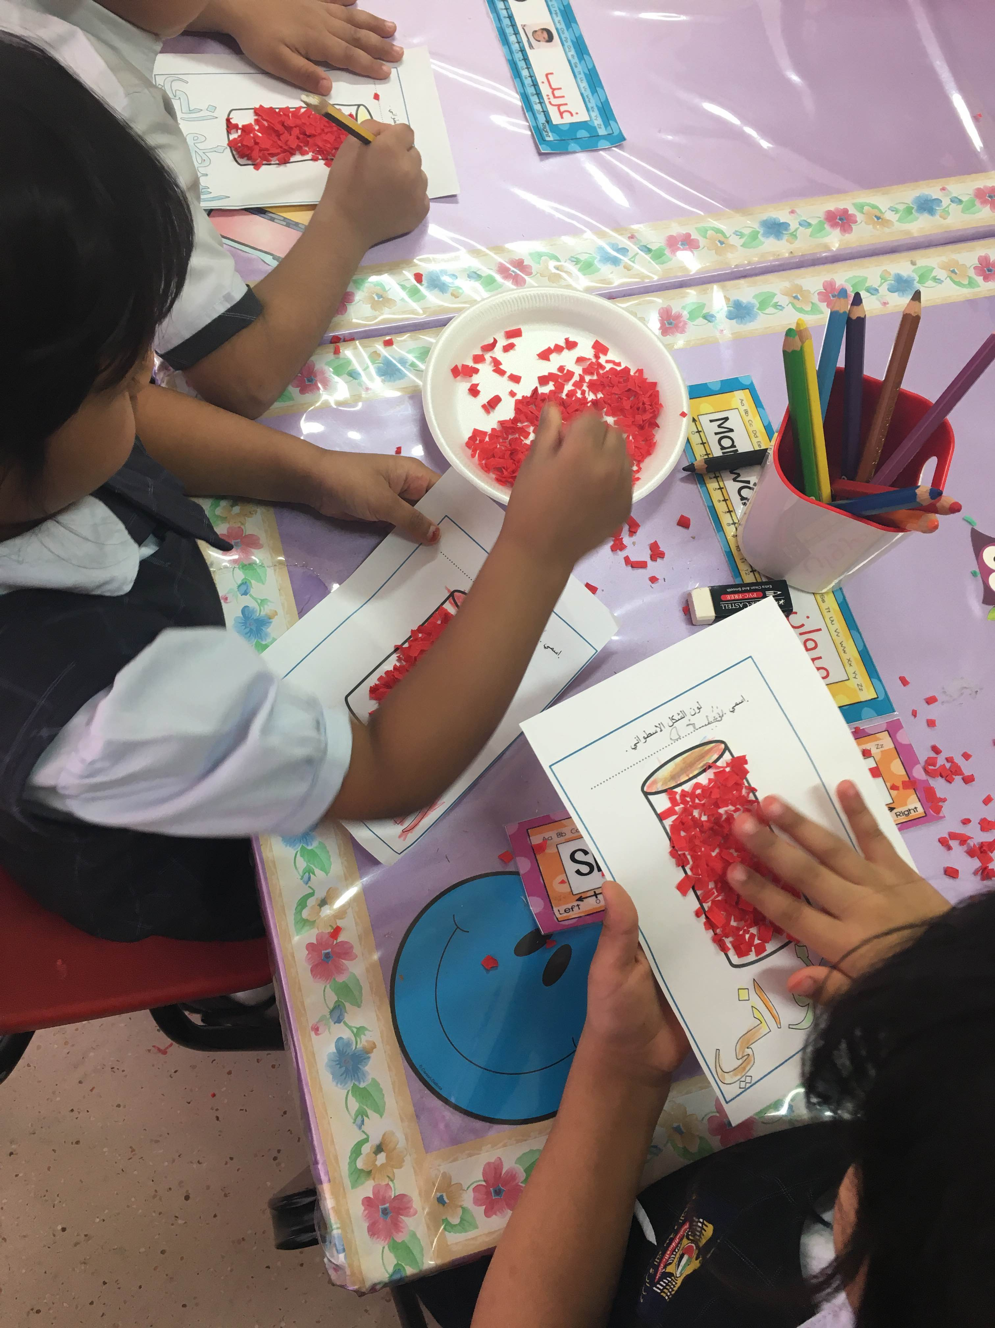 | The teacher tells the students to make two lines for boys and girls and stand on their numbers (each student has a number on the floor to stand on it). If they didn’t listen to her and make a line, she tells them again “make a line” in a very loud voice and she uses the bell to grab their attention and do what she says. | - The numbers on the floor helps students to stand in order according to their heights and not fight on the place.  - When the teacher uses the bell, she grabs children’s attention to listen to her and do what she says. | - I suggest the teacher to be stricter with children, and because this class is a new class and the teacher is also a new teacher there are no rules and specific strategies to manage the class. So I think the teacher better use something that will grab students attention to know that they have to go to the toilet or playground e.g. she can use the bell as a tool to let children know they must make a line instead of using it to let them listen to what she says so when they hear the bell is ringing they immediately stand in the line. Moreover, she have to sit consequences of those who are not making a line when they hear the bell e.g. taking five minutes from their playground time to sit in the literacy area and read a story. I think that is really a good consequence.
3 | Moving from the carpet to the centers. | After explaining the lesson, the teacher tells children that it is time for moving to centers. The teacher divides students into groups to do the activities and she tells the students who were naughty during the lesson that they are not going to do activities in the centers. She see the children who are sitting well and not talking then she calls their names to move to a certain center e.g. she says: Salama, Saud, Batul and Mohammed go to the art center. | - Dividing them into groups and calling their names to move to a certain center.  - Children know the consequence of talking during the lesson and that the teacher will not let them move to the centers and everyday the teacher reminds them of this rule. | - I liked how the teacher calls the names to let students do activities in the centers. This is the best way to make children do activities equally and not fight. But I didn’t like that she leaves the naughty children do nothing in the carpet. I suggest her to give them an activity to do instead of letting them sit on the carpet without doing anything. I always recommend the good consequences that help children learn instead of preventing them to do anything.
4 | Moving from the tables (snack-time) to the carpet then dismissal. | After they finish doing the activities in the centers, the teacher tells them to sit in their places on the tables and have their snacks. And when they finish their snacks, she let them sit on the carpet, and she calls the helping hand of the day to help her give the students their bags. After that, when it is time to go home she calls the students’ names of the first bus to stand in a line and wait till the bus’s leader comes to take them and when they leave she calls the names of the second bus and so on. | - The teacher repeat saying “if you finished your snack sit on the carpet”.  - Calling each bus’s students names in order that will make children know that they have to go in that bus. | It is better if the teacher let all children stay on the table while eating the snack and move at once to the carpet when everyone finishes the meal, because from my observation children who finishes early move a lot from their places and some of them go to drink water without asking. Moreover, the teacher should sit with them when they move from the tables to the carpet because she is always busy with something else while children are having their snacks.
