The Structure of a Complete School Day

Photograph and describe what the teacher does and what the children do at each stage of the school day, which should be clearly marked by a transition from the beginning of the school day to dismissal.

Stage & Photograph | What the teacher does | What the children do
Before the assembly  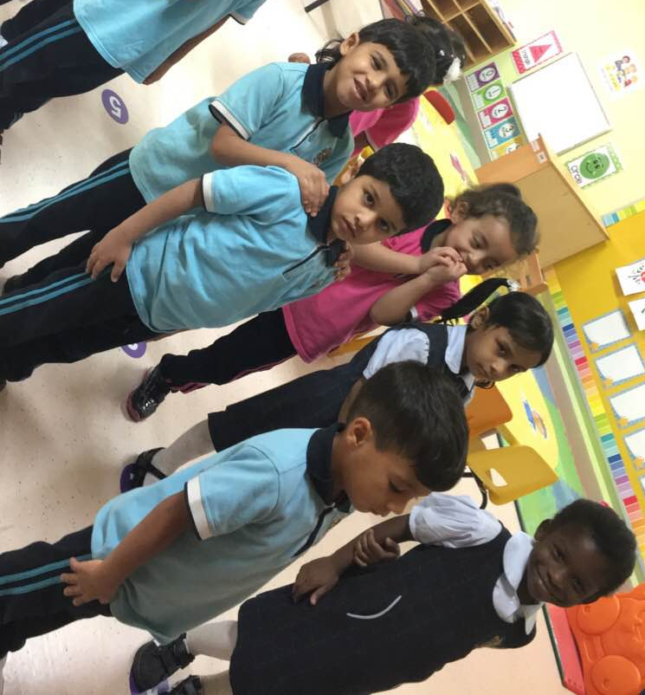 | The teacher waits till all students put their bags in the basket then she rings the bell so children stand in two lines, and she holds the first students’ hand and walk to the assembly. She also says the morning prayer with children while walking. | When students arrive the school they put their bags in the basket and put their other stuffs in the shelves then each one stand on his number that is on the floor and the first student holds the teachers’ hand. Children read the morning the morning prayer with the teacher while walking to the theatre.
During the assembly  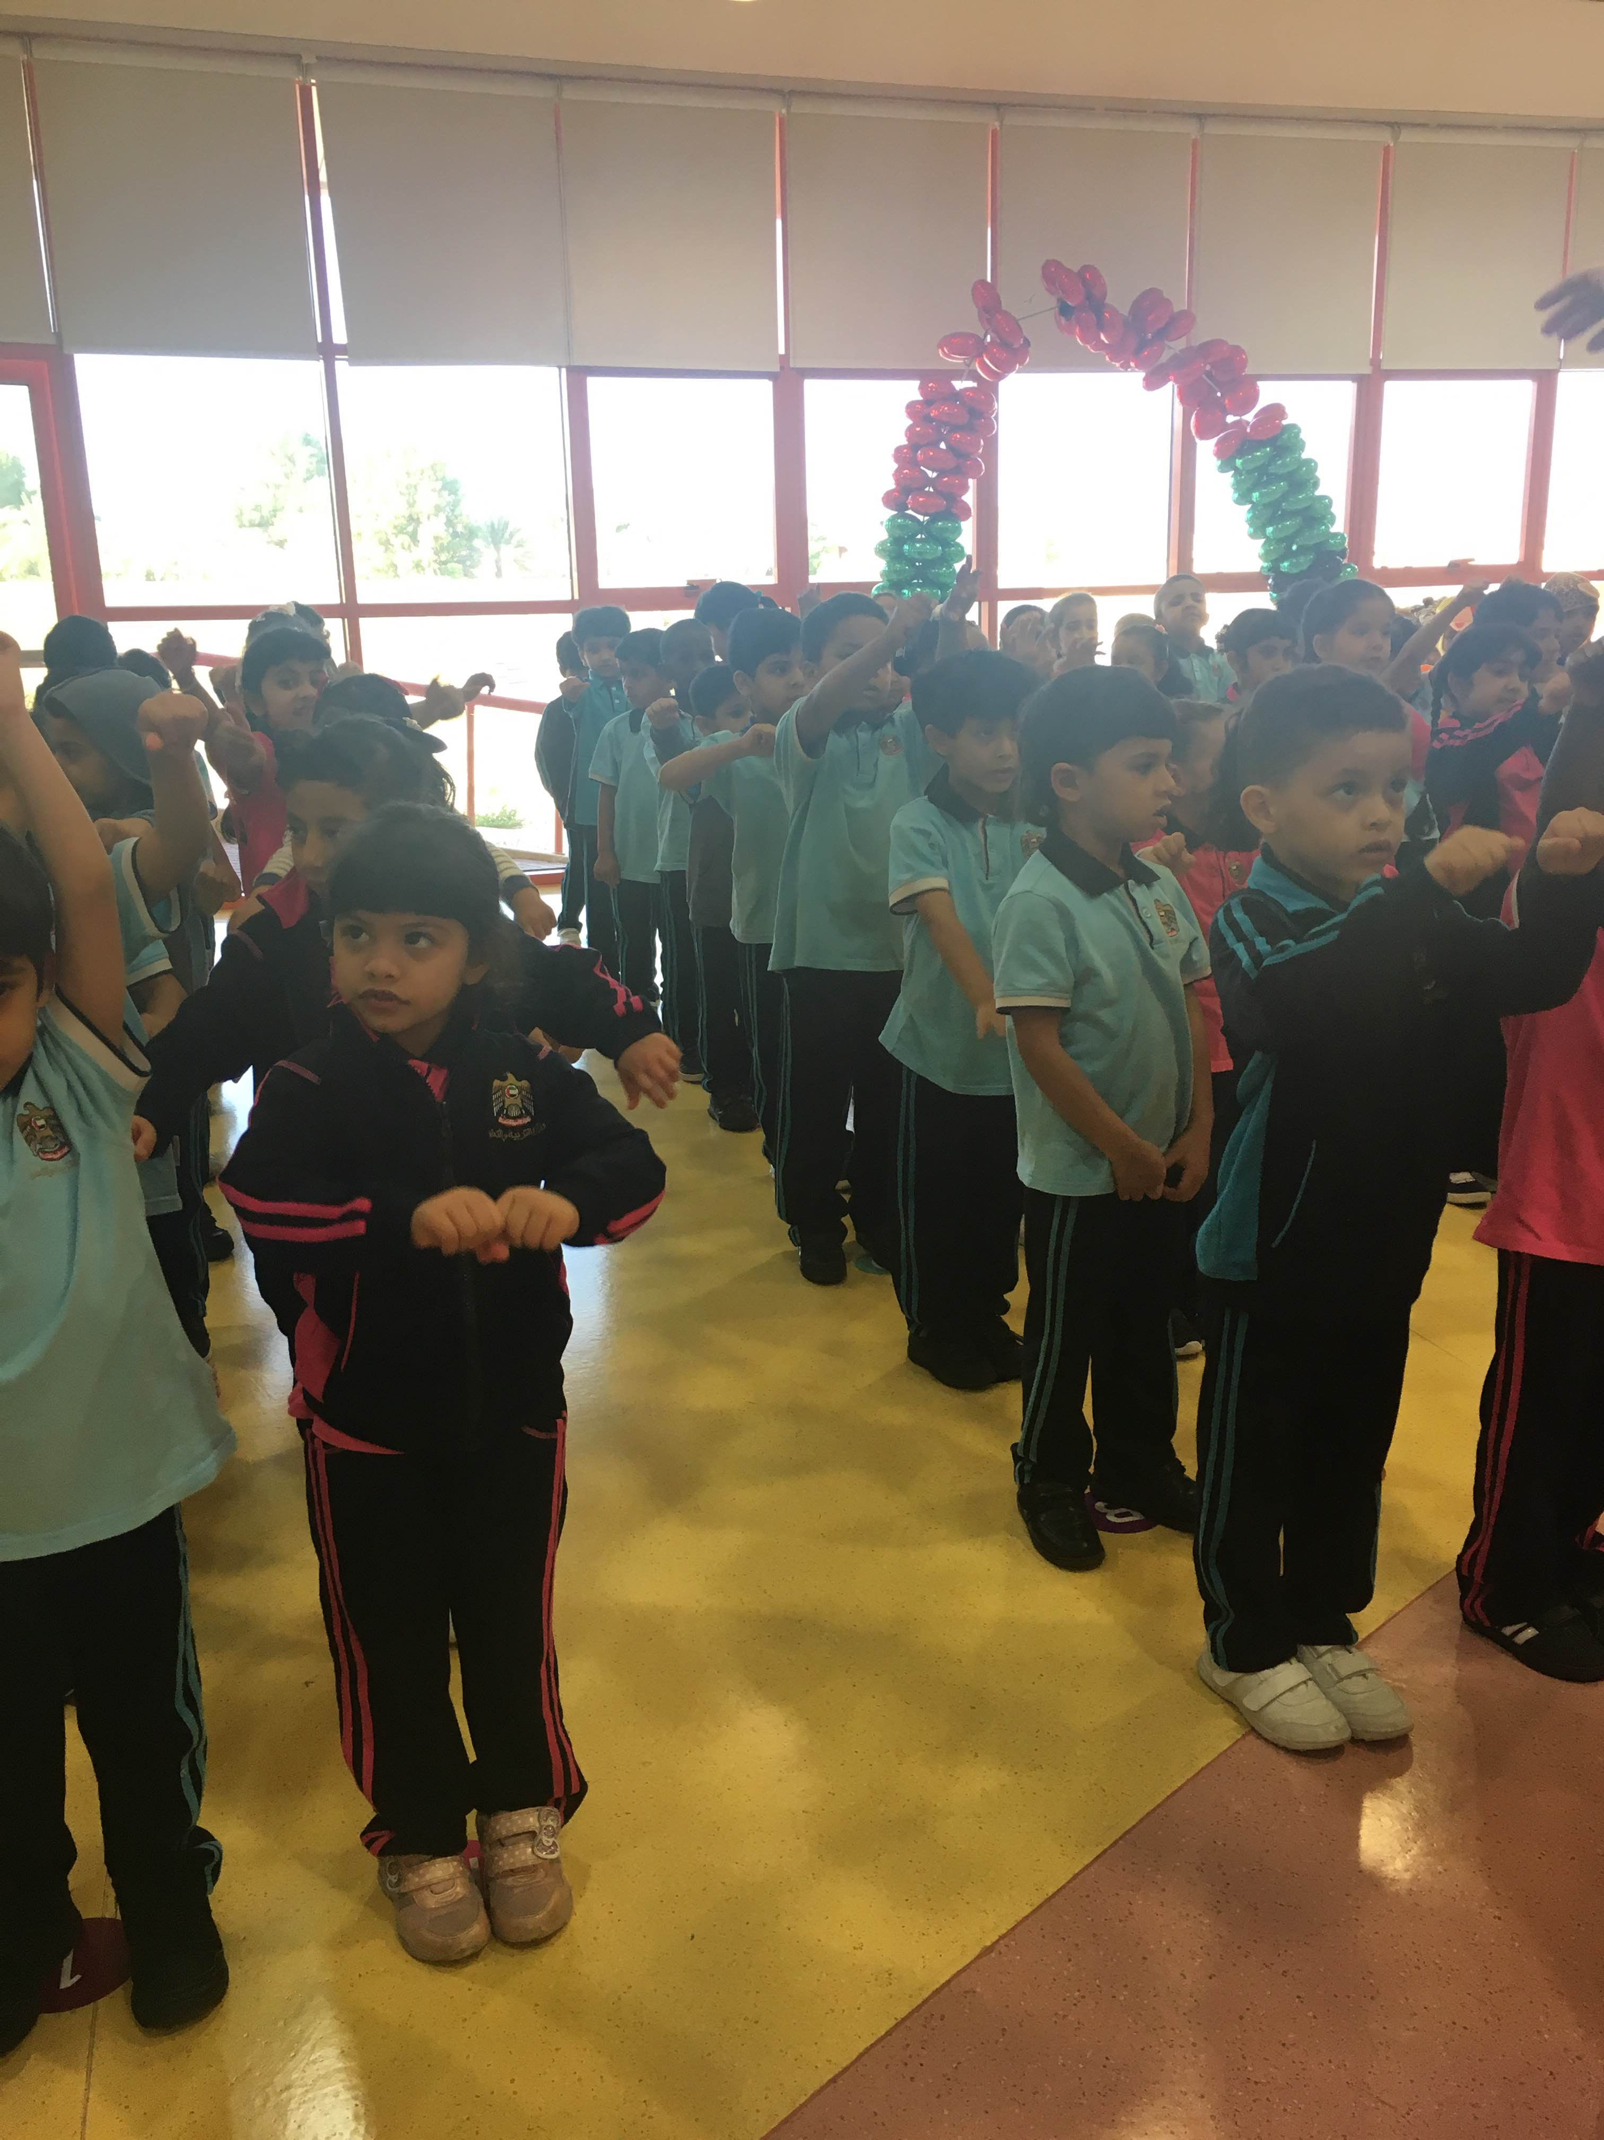 | The teacher tells students to stand well, she sings the national anthem and do the morning exercises in front of students. | Children imitate what the teacher do during the assembly. They sing with her the national anthem and do the morning exercises.
After the assembly  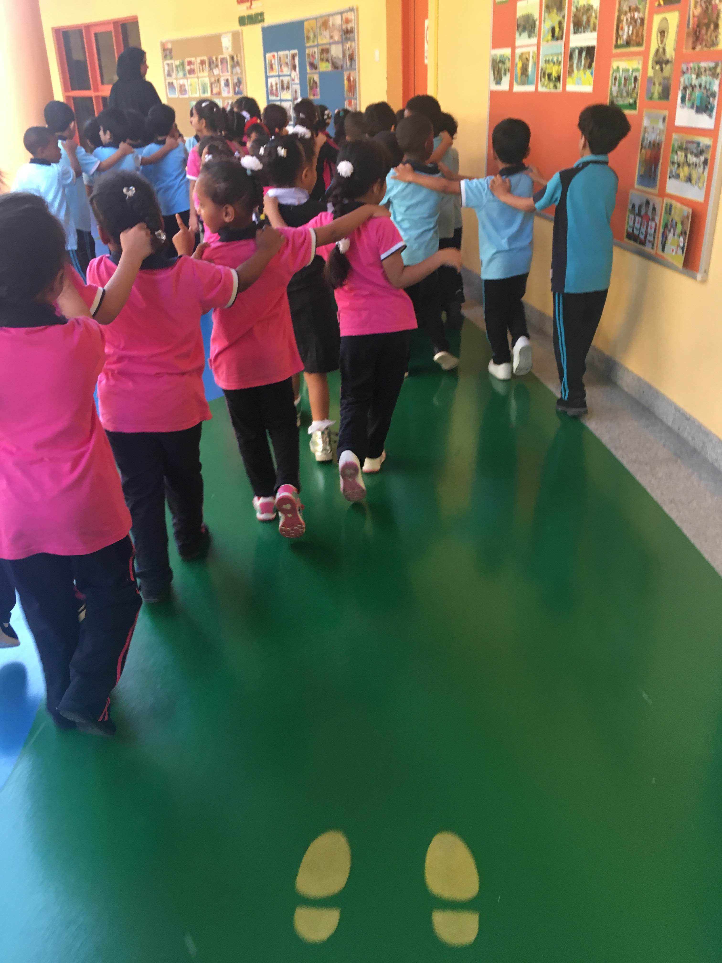 | The teacher holds the first students’ hand again and walks to the classroom. While they are walking, the teacher counts with children from 1 to 10 and they repeat again until they arrive the classroom. | Children hold each other and walk to their classroom. They count numbers with the teacher while she is counting.
Playground time  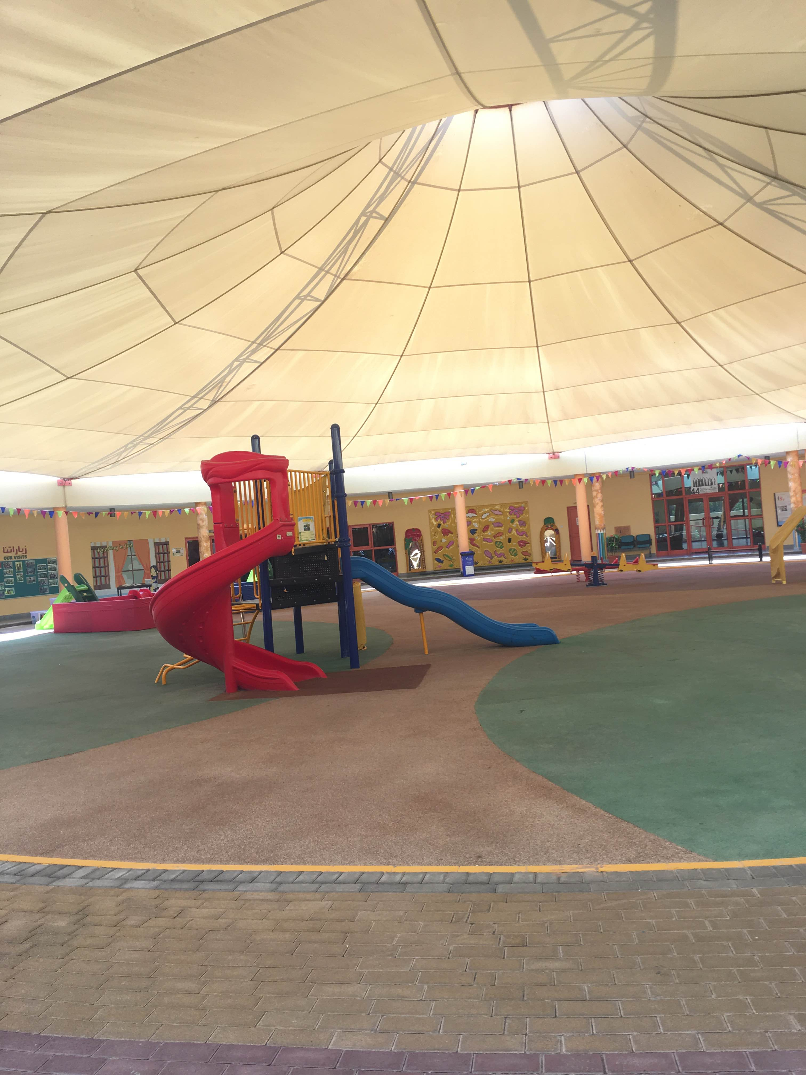 | The teacher rings the bell and tells students to stand in a line to go the playground.  Everyday in the playground the teacher observe a specific part in it e.g. the slide game part in the first half of the break time. Then in the second half another teacher alternate to observe that game. | When children hear the bell they immediately stand in two lines of boys and girls, and when the teacher tells them to go they run to the playground.  In the playground they can play at any game they want
Meal time  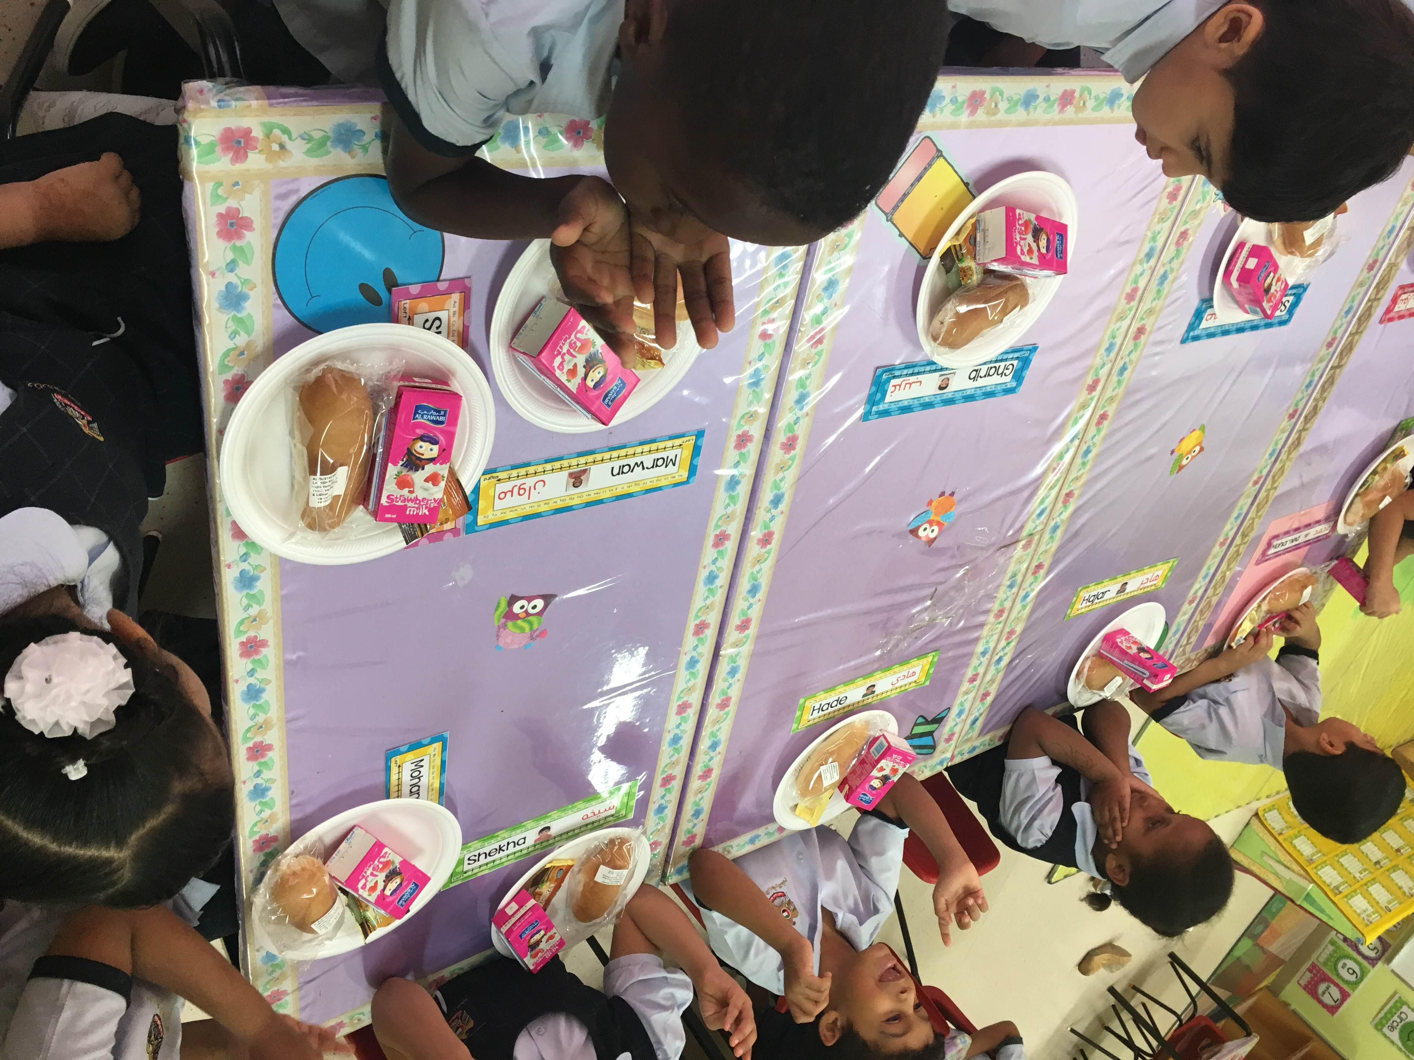 | After playing in the playground the teacher stands in front of the classroom door and wait till all children come and stand in a line.  When all students come, she puts in their hands soap to go and wash their hands. | When children hear the school bell, they know that the playground time is finished and now it is meal time. They go and stand in a line in front of the classroom to put soap in their hands and wash it before the meal.  When they finish washing their hands they stand again in a line and wait their friends to come then they go to the classroom and sit in their places on the tables and they read the food prayer before eating it.

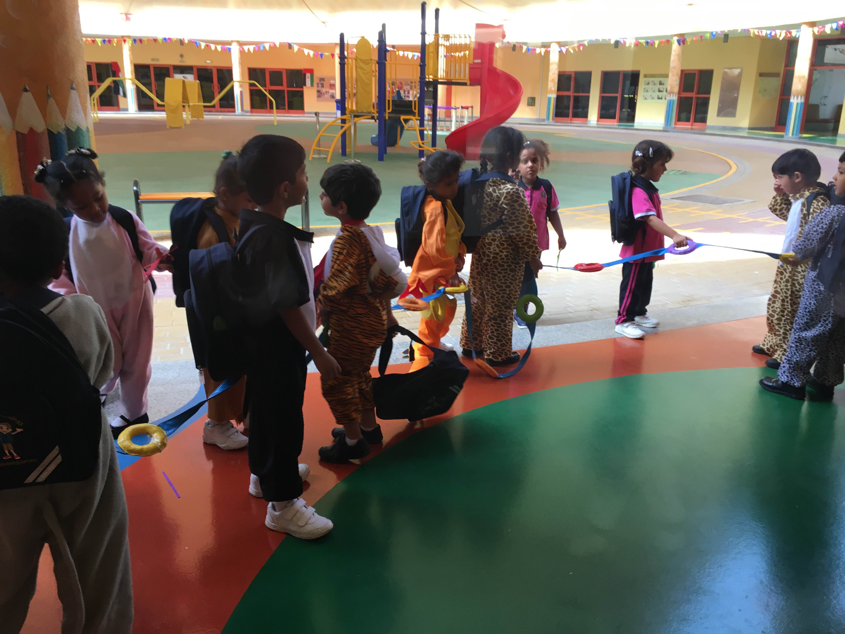  Dismissal time | The teacher gives each student his/her bag and tells them to sit on the carpet and wait until the leaders of the buses come. | Every time a leader of a specific bus comes, she calls the students names of that bus and they stand in a line and go with her to the bus.

