Task 4 – Instructional Planning
This task asks you to identify the formative and summative assessment strategies used during a week. As part of this task, you are required to implement a new formative assessment strategy, provide evidence of implementation and reflect on the impact.
What are the components of a learning outcome/instructional objective?
- Children will be able to pronounce the L-blends.
- Children will be able to write words with L-blends.

List the assessment strategies used for English, Math and Science in 1 week.
Learning Outcome | Formative Assessment Strategy/strategies | Formative Assessment Strategy explained | Summative Assessment Strategy
- English (L-blends)  - Children will be able to pronounce the L-blends. | - Using thumb up/down sticks.  - Asking questions about the lesson. | - The teacher gives these sticks to the students at the end of the lesson and as them questions like: do you know how to pronounce this word? And students use thumb up if they know and thumb down if they don’t know.  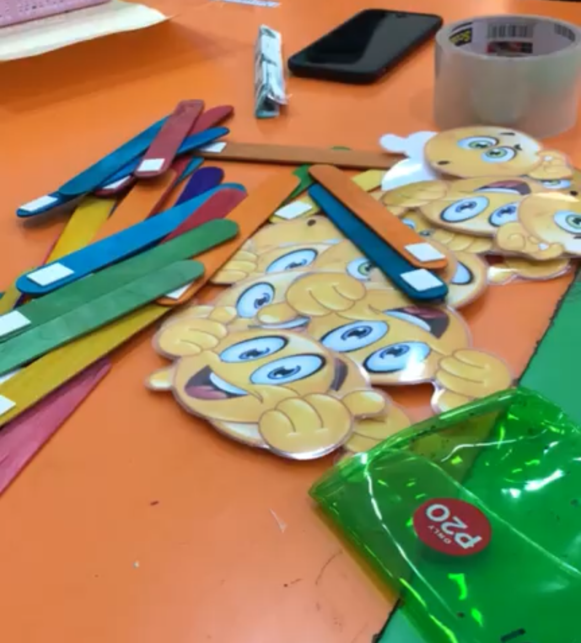 | - This lesson was a part of their English mid-term examination. They had to circle the correct L-blend for each picture.
Math (ordering numbers)  -Children will be able to order numbers from 1 to 100. | - Asking questions.  - Raised hands strategy. | - The teacher at the end of the lesson wrote numbers on the white board and asked a student to order the numbers, she said: who can help me to order these numbers?  And she asked them to raise their hands. | - This lesson was a part of their Math mid-term examination. They had to order four numbers (3,14,55,70) from the least to the greatest.
English (common and proper nouns)  Children will be able to differentiate between the proper an common nouns. | - Activity.  - Checklist. | - The teacher did an activity at the end of the lesson to check on their understanding of the lesson. She gave each student a sticky note that has a proper or common noun on it. Each student has to read the word and determine if it is a common or proper noun. The teacher displayed on the smart-board two circles titled with proper noun and common noun, and each student should stick the sticky note on the right place on the smart board. She used the checklist to see if they know how to differentiate or not. | - This lesson was a part of their Math mid-term examination. They had to match the proper nouns with the word (proper nouns) and match the common nouns with the word (common nouns).

