TASK 4

A List of resources that target specific scientific skills and concepts in the school:

Resources for Science teaching classroom: | Scientific Skill(s) / Concept(s) that can be developed with it. | Exploring on possible activities to develop scientific skills and concepts using these materials
Magnets  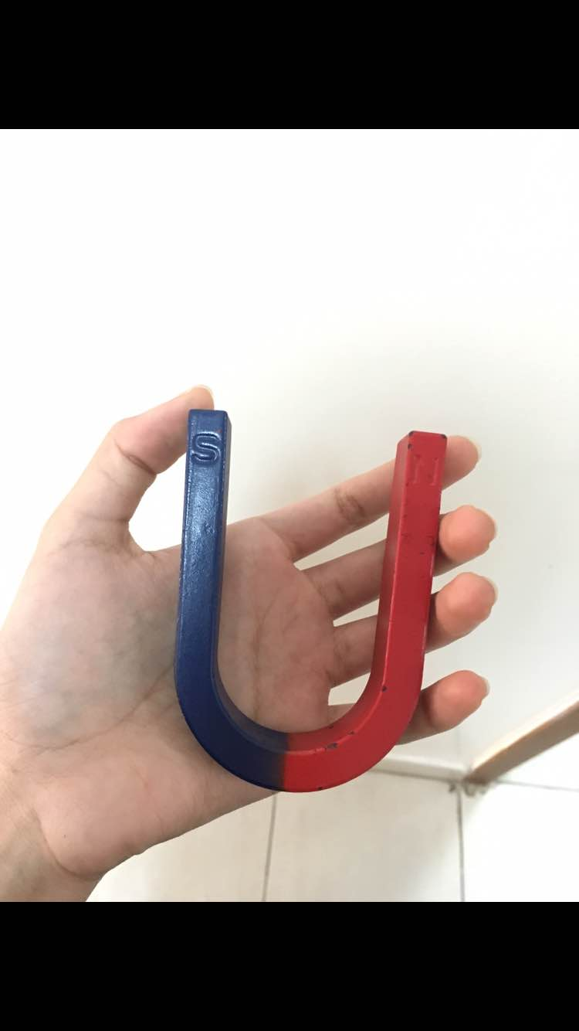 | Magnets are made of iron and they catch iron materials like pins and iron filings. Magnets also can attract each other depends on which way the poles are aligned. They cannot attract other materials that are not made from iron like glasses, plastic. | Using the magnets to explain how the earth attracts objects and living creatures as well as the magnets attract the iron things. Letting students to discover the things that can be attracted by the magnate.
Magnifying glasses  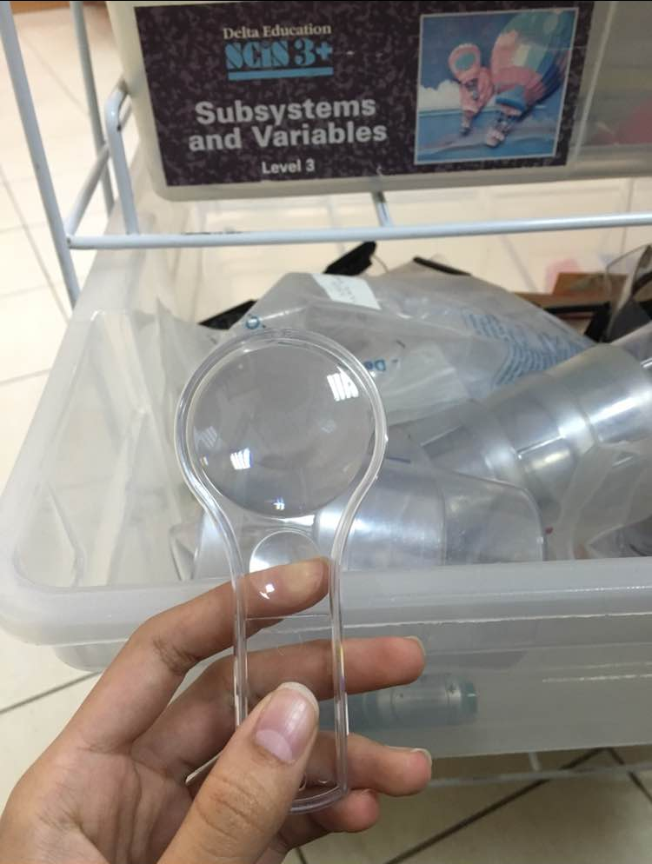 | Magnifying glasses are made from glass. They make things look bigger than their real size. We can see the small things bigger by using the magnifying glasses. | Letting students discover small things using the magnifying glasses like insects.
Electric circuits | Electricity can flow through the components in a complete electric circuit. The electric circuit always needs a power source, such as a battery to light up the lights. | Students will be able to use the electric circuits under the eyes of the teacher. They will discover how to use it by themselves. Using it they will discover that the power of the battery can light up three lights.
Goggle  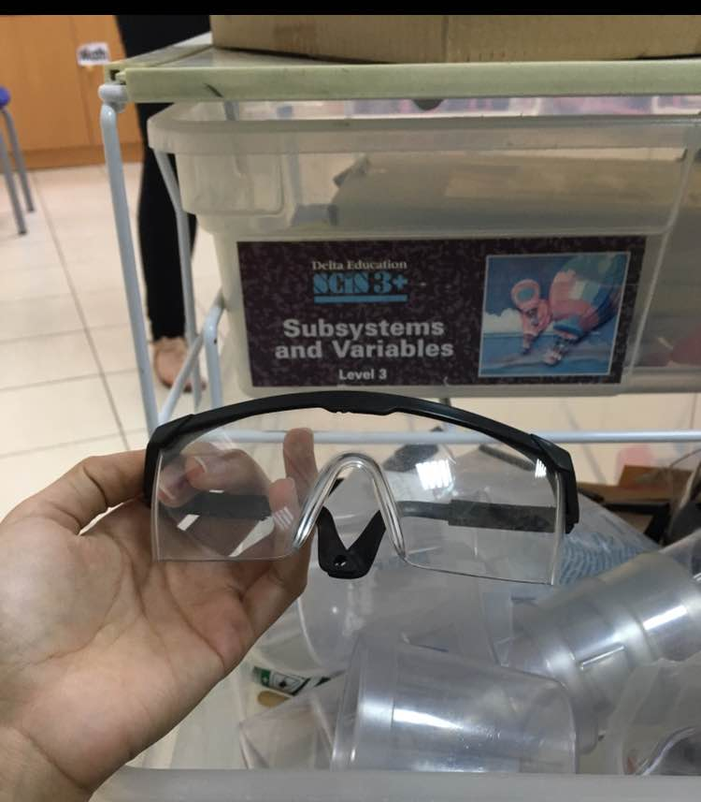 | Goggles are made from safety glass. It protects the students’ eyes from the dangerous things that could come in their eyes while making an experiment. | Using it while doing a science experiment especially the chemistry experiments.

Table 5: Learning styles

Make notes about activities you observe in the classroom which use the learning styles below:

 | Math | Science | Reading
Auditory | - Using the audio before the math quiz to tell the instructions  - The teacher chooses a student in each math class to read the math equations, the rest of the students listen and repeat. | - Playing a video that talks about the five senses  - The teacher plays a recording about the animals’ sounds. | - Students listen to the teacher while she reads a story.  - The teacher read the new words in phonics class and the students listen.
Visual | - Using 3D shapes for the geometry lesson in math class.  - Drawing things on the board for counting (for example three apples). | - Showing the students pictures of animals.  - Playing a video about the animals. | - The storybook has pictures about the story. For example: a story was about the snowman so the students could see the pictures of the snowman.
Kinesthetic | - Letting students to solve the addition and subtraction equations on the board. | - Letting students to push and pull the door. | - While reading a story, some words describe movements, for example: the girl ran away, the students acting like they are running in their places.

Answer the following questions:
- Which learning styles did all the children seem to enjoy and why?

Musical: every time the teacher reads a story, there is always a sound, for example: the bell rings (ring ring). And they start repeating the sound and laugh. Because it is funny and enjoyable for them to listen and repeat.

- Why do you think the teacher incorporates a variety of learning styles for the children?
Because each student has a different learning style. She tries to use most of them to grab their attention.

- Notice which activities are repeated with a variety of learning styles e.g. read a story, listen to a story, act the story, draw the story. Can you find other examples e.g. math or science

- Reading the story words.
- Reading the math questions.

- How can teachers improve student learning by using a range of learning styles?
- Doing different activities that allow the students with different learning styles to participate.

The scientific concepts that covered through out the year:

- Life science – the five senses, animals
- Physical science- push and pull
- Earth science- sunrise and sunset, weather.

