TASK 3

Table 4: reframing behavioral characteristics:
Name of child | General behavioral characteristics | Reframed | Suggestions to help improve behavior?
1. Mahra | She always moves from her place and disturb her partner and talk with him | - She may feel bored and wants to play.  - Maybe she wants someone to listen to her. | - If she kept doing this, the teacher should change her place and bring her in front of the classroom.
2. Khalfan | He is quite and doesn’t participate in the class activities. He also doesn’t read while others are reading together. | - He may feels uncomfortable because he thinks that other students better than him.  - Maybe he is not listening to the teacher and thinking of some thing else | - Maybe asking him questions will help him to focus.  - The teacher should explain him the instructions clearly.
3. Roqaya | She always cry if she didn’t know how to solve a math equation. | - Maybe she wants to be perfect and not having a mistake | - Encourage and tell her that she can do it. And if she didn’t know, the teacher should tell her that we all make mistakes so it is okay.

Table 6: mathematical recourses in the classroom:
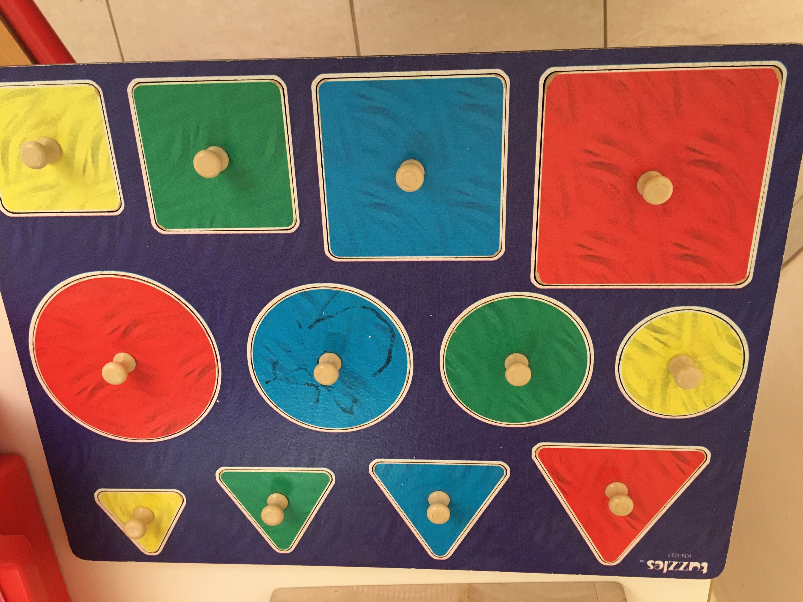
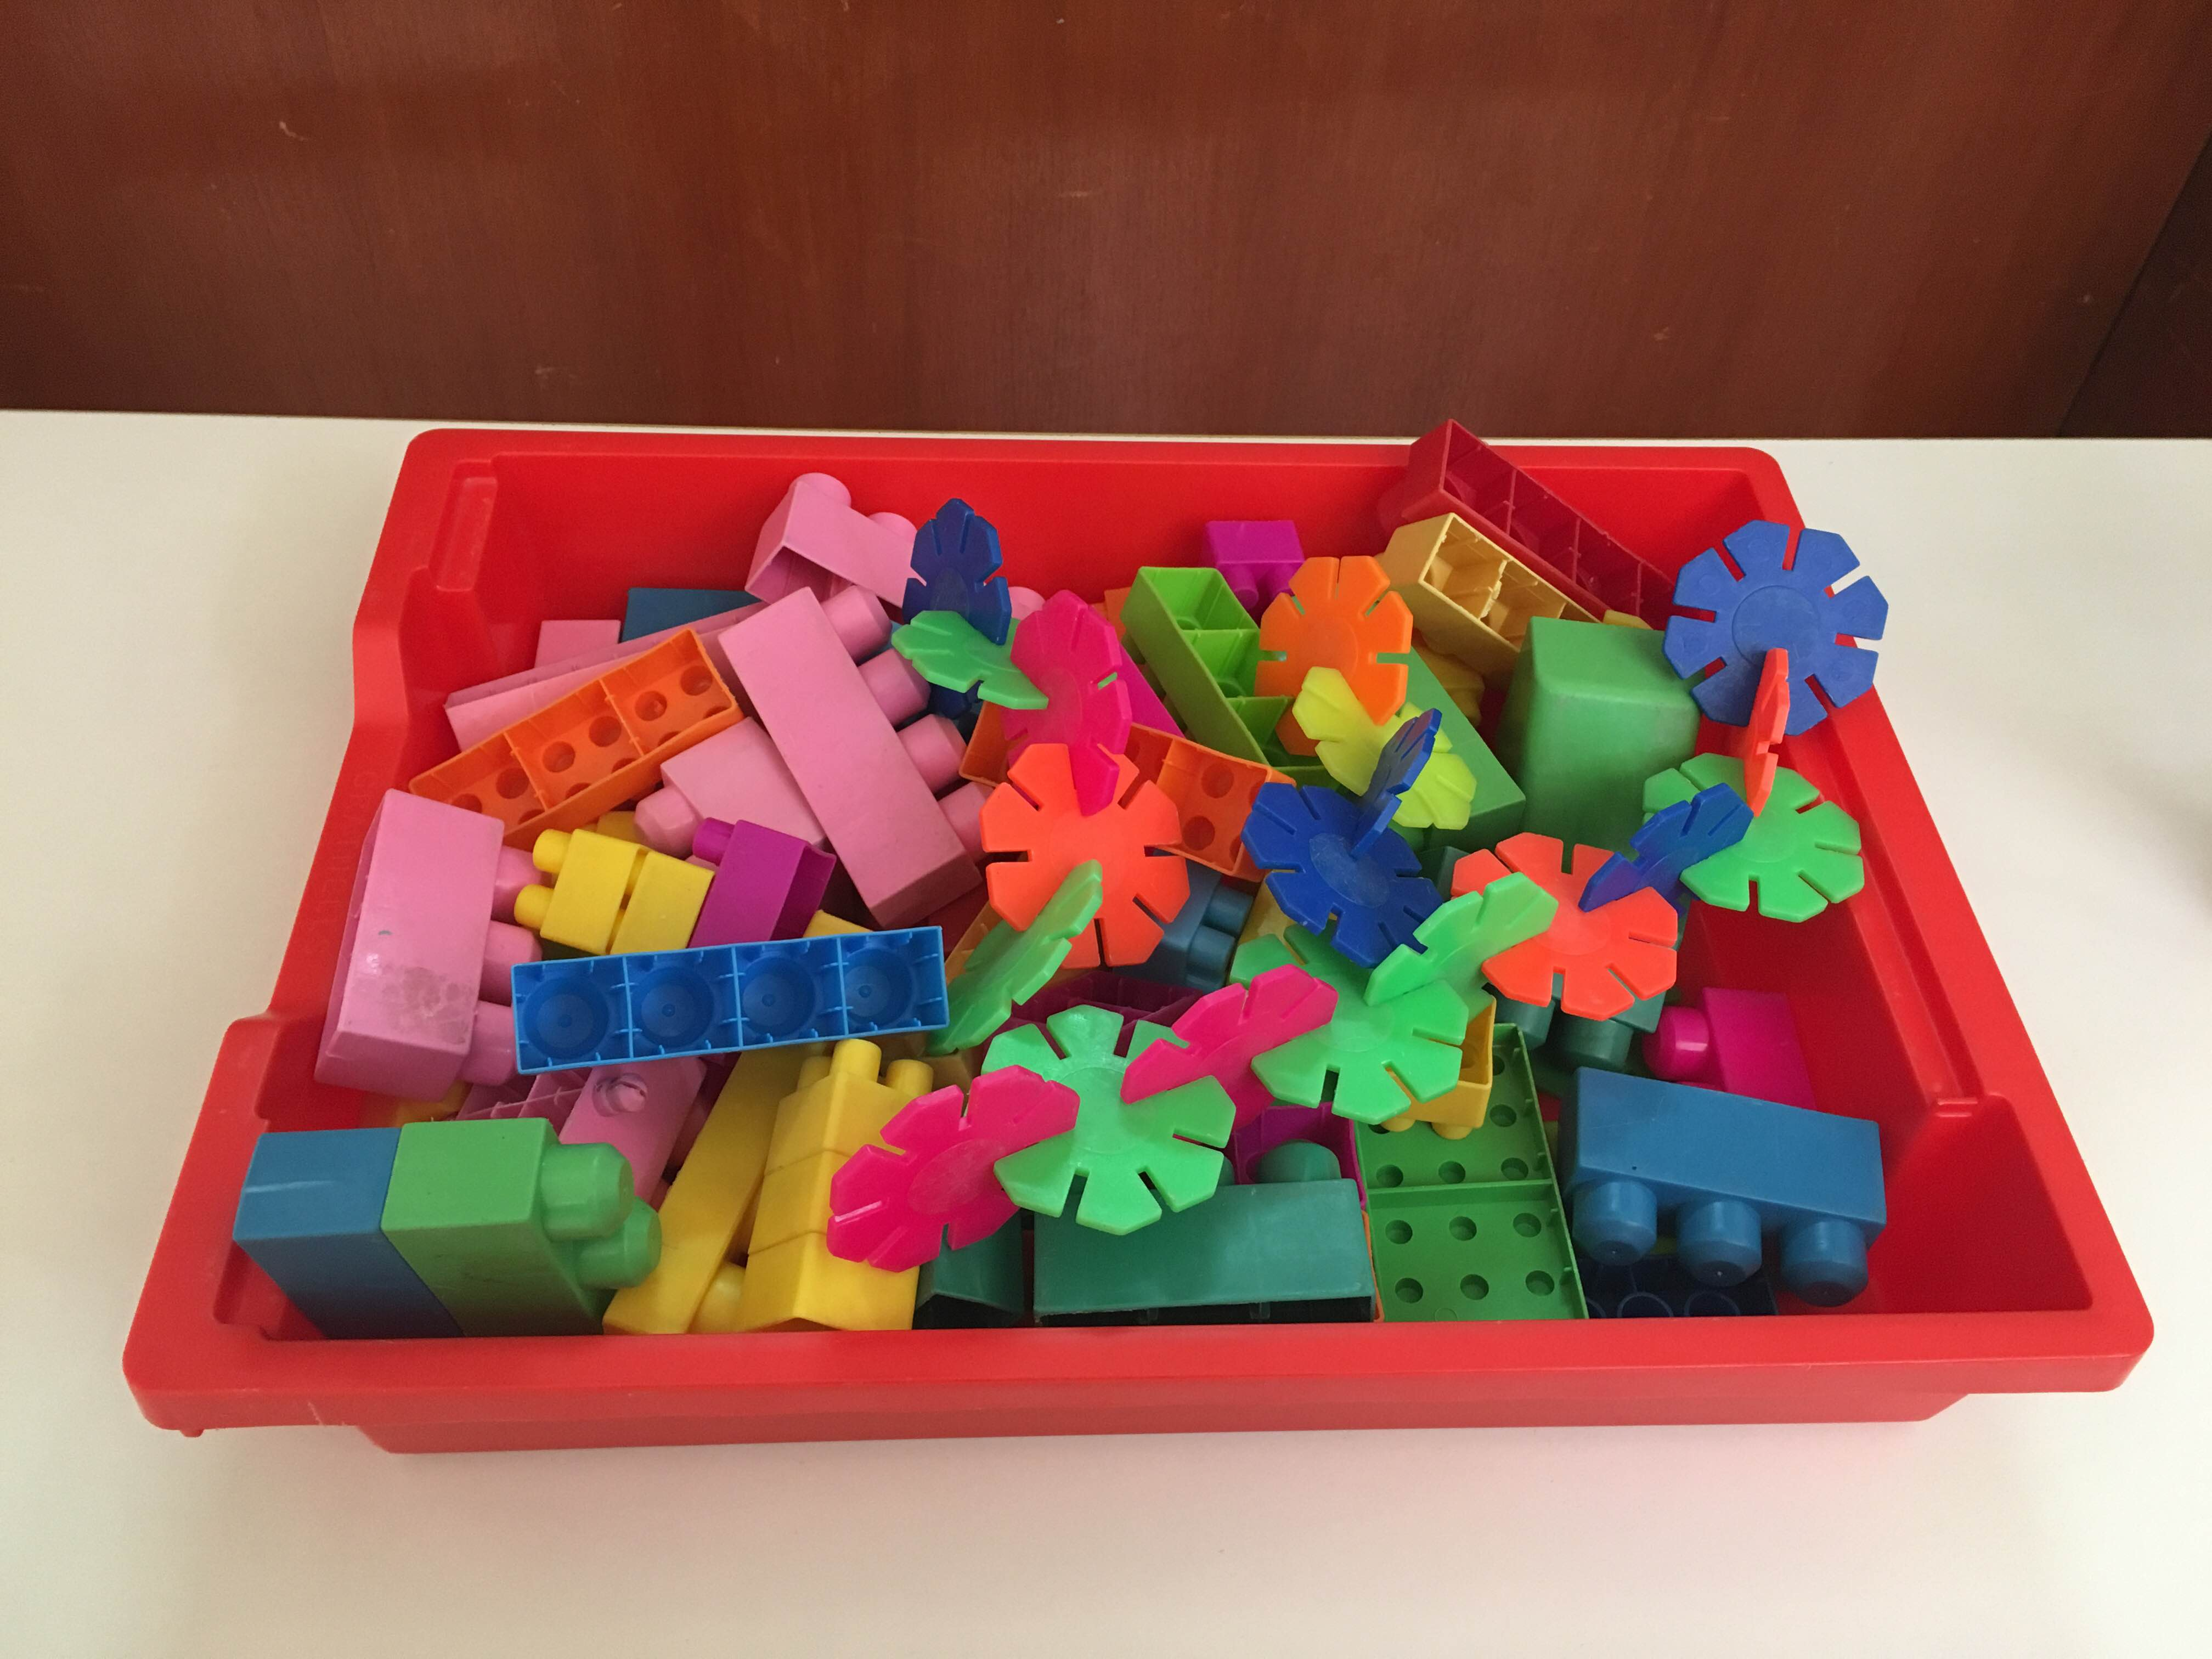
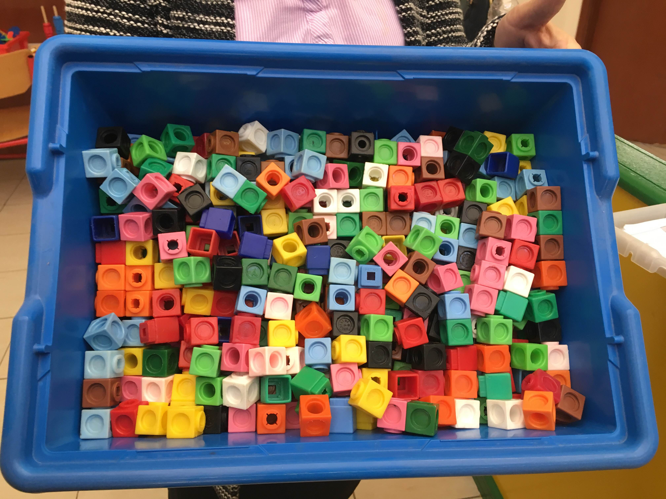
Mathematical recourses | Mathematical skills/concepts that can be developed with it | Exploring on possible activities to develop mathematical skills and concepts using these materials
1. Cubes | Learning how to count.  Comparing sizes (bigger-smaller).  Sorting according to colors.  Measuring length.  Addition and subtraction. | Asking the students to create a building of 6 cubes.  Classify the cubes according to their colors.  Asking the students to use the cubes to create patterns.
2. Wooden Shapes with various sizes, shapes and colors | Counting  Ordering, creating patterns  Naming shapes and colors  Comparing sizes (bigger- smaller) | Showing the students the shapes to name the shape and the color.  Giving each group of students the shapes to create a pattern.
3. Various colors and shapes | Comparing sizes and colors.  Counting, calculating (including more/less than)  Addition, subtraction  Classify  Creating patterns | Giving students different shapes and they classify them according to their colors  Counting the numbers shapes of each color.
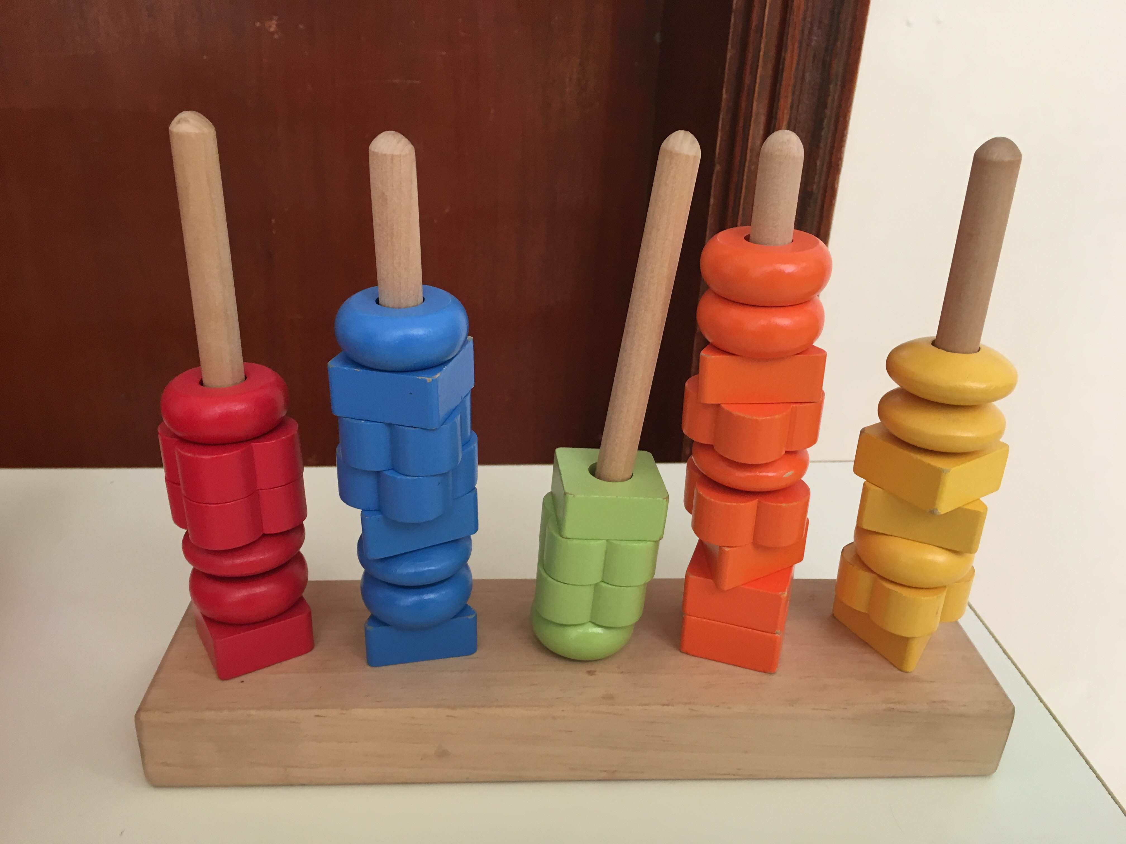

Math concepts covered throughout the year:
- Counting
- One to one correspondence
- Addition and subtraction
- Comparing

Complete a math activity with a group of children:
Picture graphs:

- What recourses did they use?
They used a poster that has pictures of 3 fishes (orange fish, blue fish, pink fish). They answered the questions underneath the picture graph (three groups of students).

- How did the children learn?
They learned by counting the fishes and re-reading the questions to answer.

- Did they work individually, in pairs or groups?
They worked in three groups.

- What did you do?
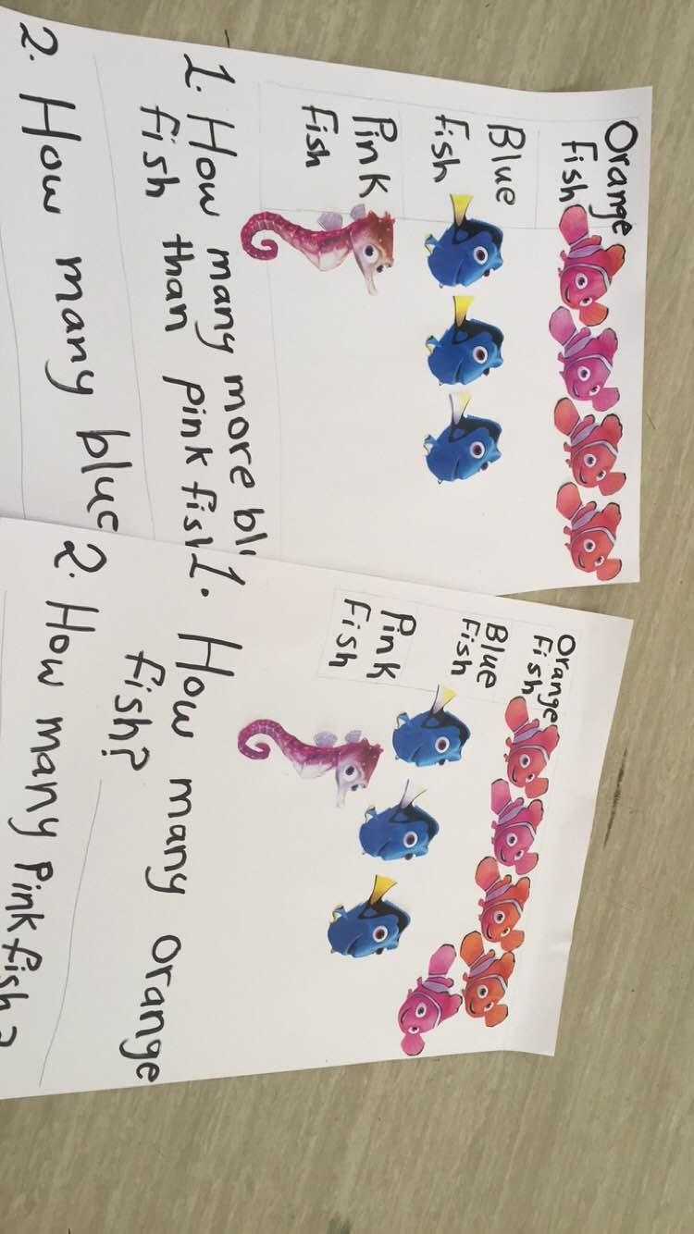
I read the questions for them and helped them to answer the questions.

