TASK 1

Table 1: School Profile
Name of school: International School Chuoeifat Location: Umm Al Quwain
Principal: Mrs. Margaret Guilfoyle (Masri)
Tel: 7665888 Fax:06-7662088
Address: Al Hamra area PO Box: 3142
Teachers’ Starting Time: 7:45 am Finishing Time: 4:00 pm
Students’ Starting Time: 8:00 am Finishing Time: 3:10pm

Total Number of Classroom Teachers in the school Department: (Kg1 & Kg2)
Total Number of Children in the Preschool Section: 374 students
Teacher / student ratio: 1 teacher in 1 classroom and 1 assistant (28 students)
Number of Classrooms: 14 classrooms in the infant section
Facilities available to student teachers:
- Canteen
- Office
- Teachers room

Class for this Practicum: 1D
Mentoring Classroom Teacher: Grade 1 class teacher – Ms. Carol
Classroom Teaching Assistant: Ms. Janeit
Number of children in this class: 28 students
Number of children identified as having SEN in this class: -
Additional information: e.g. English, Arabic, Islamic Studies teachers
- English, Science, Math: Ms. Carol
- Arabic, Islamic: Ms. Manahel

School Nurse: Ms. Nisha School TP Coordinator: -
Librarian: -
Resource Room Manager: Mr. Nishar

Table 2: Map of indoor learning
Class board
Teacher’s desk
Students’ tables and chairs
Students’ stuffs Shelf

Classroom door
Windows
Story new words and pictures board
Math equations board
Phonics words board

Table 3: Classroom Rules
Classroom Rules | Reframe using positive language | Opportunities to teach theses rules
1. Do not disturb your friends | Be nice with your friends | - Repeating the rules every morning  - Using meaningful images to let students understand the purpose.
2. Do not shout out to answer | Always put up your hand to answer | - When a student shout out and doesn’t raise his hand to answer, the teacher reminds him of the rule so he and the other students can remember the rule and not repeat this habit again.  - The teacher praises children who follow the rules
3. No pushing in the line | - Respect your friends in the line | - While students are lining up to go to the playground or the toilet, the assistant asks them about the rule of lining up.
4. Do not play with water in the bathroom | - Save the water in the bathroom | - Before entering the bathroom, the assistant reminds them of the rule, and if someone played with water she talks to him alone.

Class list:
The teacher didn’t agree to take the classroom students list because of confidently purposes. But what I know about the class that there are 27 students (14 boys and 14 girls)

Weekly/ daily class timetable of class 1D:
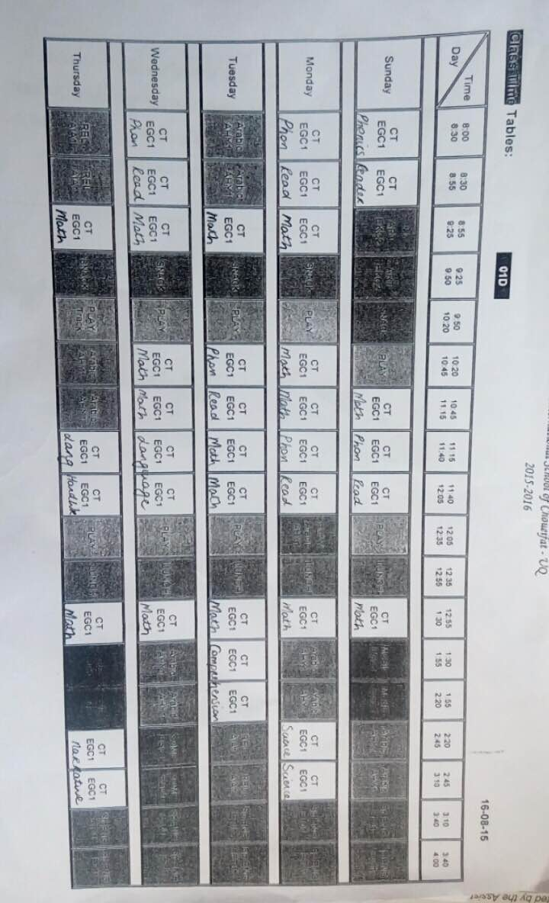

Important dates:
