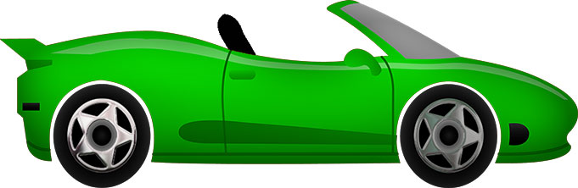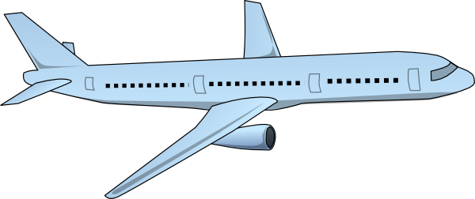 

**9 cars**

**3**

**Airplanes**

**6 buses**

**Transportation Pie chart**

1. How many cars?....................................
2. How many buses? ...................................
3. How many **more** buses than airplanes? …………………………………………………………………
4. Which transportation is there the **most**? ………………………………………………..
5. Which transportation is there the **least**? ………………………………………………..
6. How many cars?....................................
7. How many buses? ...................................
8. How many **more** buses than airplanes? …………………………………………………………………
9. Which transportation is there the **most**? ………………………………………………..
10. Which transportation is there the **least**? ………………………………………………..

**3**

**Airplanes**

**9 cars**

**6 buses**

**Transportation Pie chart**