 | Description | Rationale / Justification  (At least 2 rationales/justifications needed + Academic Literature)
Goal 1 | Improve behavior management during transitions inside and outside the classroom (transitions between the activities, transitions from the classroom to the playground and bathroom, and back to the classroom). | I want to develop my classroom management especially the behavior management during transitions for two reasons. First because in the previous teaching practices I faced difficulties in dealing with misbehaved students during transitions, so I want to learn more about managing behavior. Second, I want to learn behavior management not only for me to see my students well managed, but also for my students to learn how to be more organized and manage their behavior and be independent from their childhood until they grow up, so they will not face difficulties in the future. For example, if children learned how to ask the teacher for permission before moving (going to the bathroom) they will be more disciplined since this age which means they will be more respectful. According to Angele Passe, “Making the transition into kindergarten is a significant and exciting milestone in young children’s lives. With proper coordination and planning, it can be a smooth process, benefiting children, families and schools” (Passe, n.d.). Learning strategies to help students move smoothly from an area to another is not easy and it needs patience. I will keep improving myself until I know the best way and it is fine because even teachers make mistakes so I will keep on till I improve it. If something didn’t work well I will keep on trying new things.
TP Competency | Managing learning (classroom management – behavior management)
Action 1 | Improve managing behavior during transitions using these strategies:  - Moving from the carpet to the corners by calling their names one by one with singing. For example: where is Mohammed, where is Mohammed? You can go, you can go.  - Moving from the classroom to the playground/bathroom by asking the boys and girls to make two lines.  - Transitions from the activities to the carpet by using a bell to grab their attention, and they know they have to tidy up and sit on the carpet even if they didn’t finish their work.
Time frame | Within seven weeks.
Support needed | - I will ask the teacher to support me by taking pictures and videos of me while implementing the strategies.  - I will use materials such as bell and singing songs.
How will you provide evidence of the success of the action | - Taking pictures and videos of me implementing the action.  - MST’s observations and notes.
Evidence  (After implementation) | 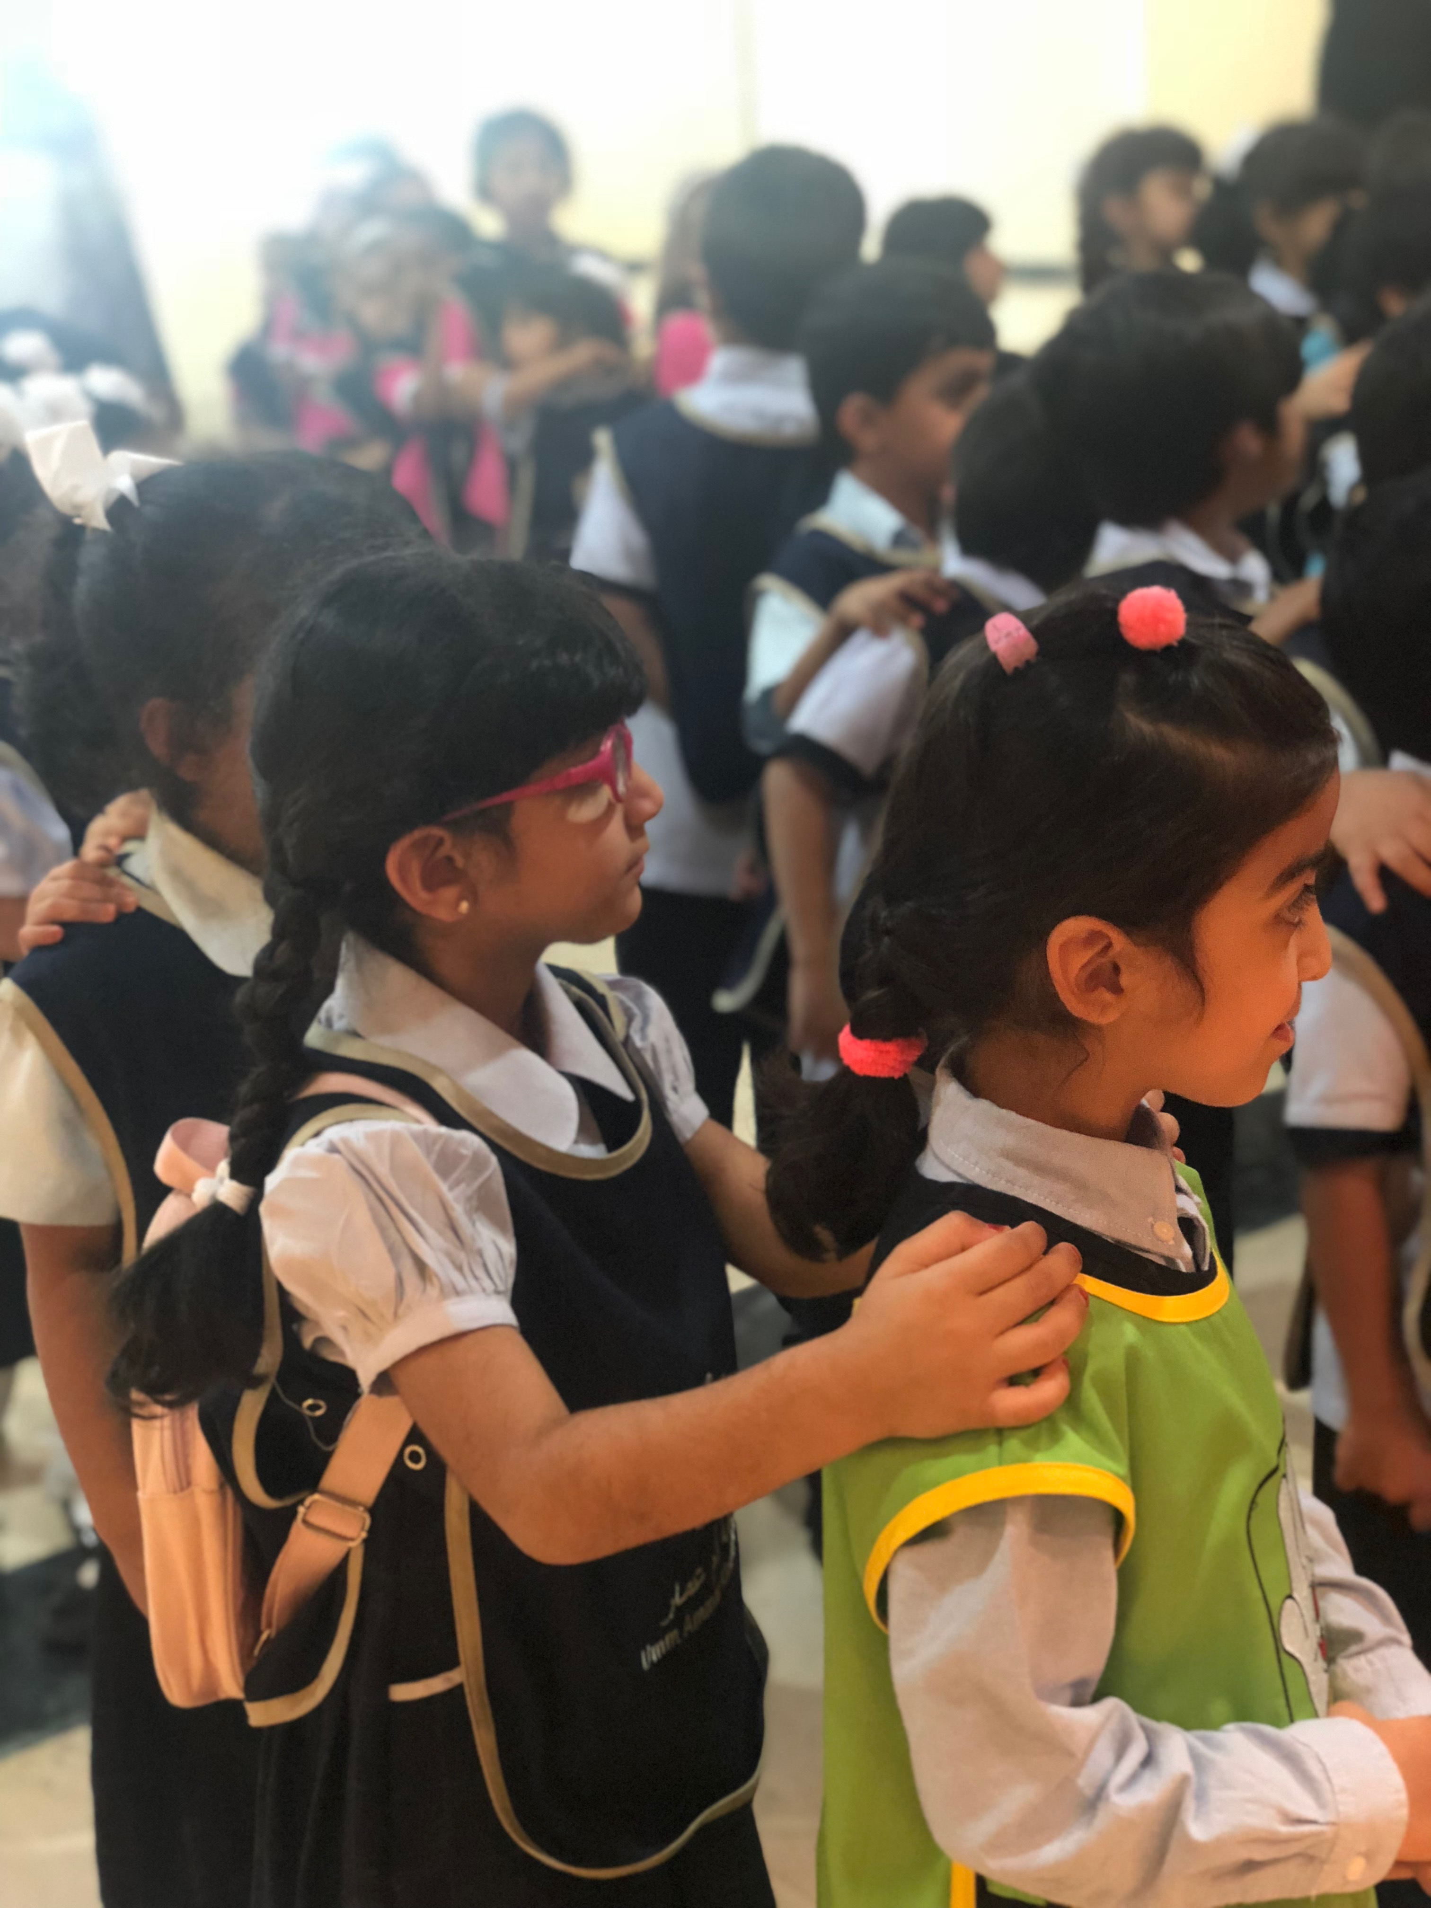  Transitions from the classroom to the assembly/playground. The teacher asks children to make two lines of boys and girls, and they have to put their hands to make a space between each other. The students who are misbehaving during transitions like pushing his/her friends, the teacher asks him/her to stand in the back of the line.
Reflection  (What happened because of this action?) | During this semester, I have improved in behavior management during transition more than before. In the previous semesters, it was hard for me to manage misbehavior during transition from the classroom to the playground/theater/assembly/ school’s cinema and coming back to the class. In this class, the Arabic teacher doesn’t have a strategy to let them make two lines for boys and girls, but I tried to us my own strategy, and I make voice louder and say line up boys and girls and they know that they have to make two lines of boys and girls. This is about the transition from the classroom to another area inside the school. But the transition inside the classroom especially from the circle time to the activities needs more improvement. The teacher in the classroom doesn’t have a strategy for transition from the circle time to the activities and the corners, she just says the name of the students that she wants them to do the activity in the group and the rest just move to the activities. These random moves might be dangerous for children because some of them push each other. So I tried to use my own strategy, which is asking each line to stand up, turn and walk to the corners. Although it was hard to make them get used with this strategy, but I tried to make them know that they have to be disciplined when they move from a place to another even inside the classroom. When I used my strategy to move from the circle time to the corners by calling the lines (this line, stand up, and go to the corners) some students didn’t listen to me and they went to the corners before I call their line, but in the next teaching practice I will try to make them get used more from the first lesson that I teach them.

Reference:
Passe, A. S. (n.d.). The Importance of Transition for Children’s Success. Retrieved from Fairfax Futures: http://www.fairfax-
futures.org/assets/files/publications/ready.pdf

 | Description | Rationale / Justification  (At least 2 rationales/justifications needed + Academic Literature)
Goal 2 | Improve my lesson plans | This semester, I want to improve my planning because in the previous semesters, I had some notes from my MSTs to improve my planning more. One of them said that I need to provide alternative activities if one activity didn’t work well. Also, I need to do one more activity for those who finish their activity quickly. So I am willing to improve my planning for the lessons. Moreover, I want to learn about making weekly plans more, because it will help me in the future as a teacher. We don’t have lesson plans only (short-term planning) we have also plans for a month, a term, and a whole year (medium-long term planning). Another thing is that I need to set achievable and realistic goals. For example, in the first three days of the week I want children to learn how to make the sound of letter m and know how it looks like, and in the last two days they will learn how to write the letter with making its sound. We can’t let them learn everything at once. According to Ministry of Education, Guyana, “Part of classroom planning is developing effective plans. A good lesson plan includes an objective or goal, the steps of the lesson, the expected outcome and room to make changes along the way” (Ministry of Education, Guyuna, n.d.)  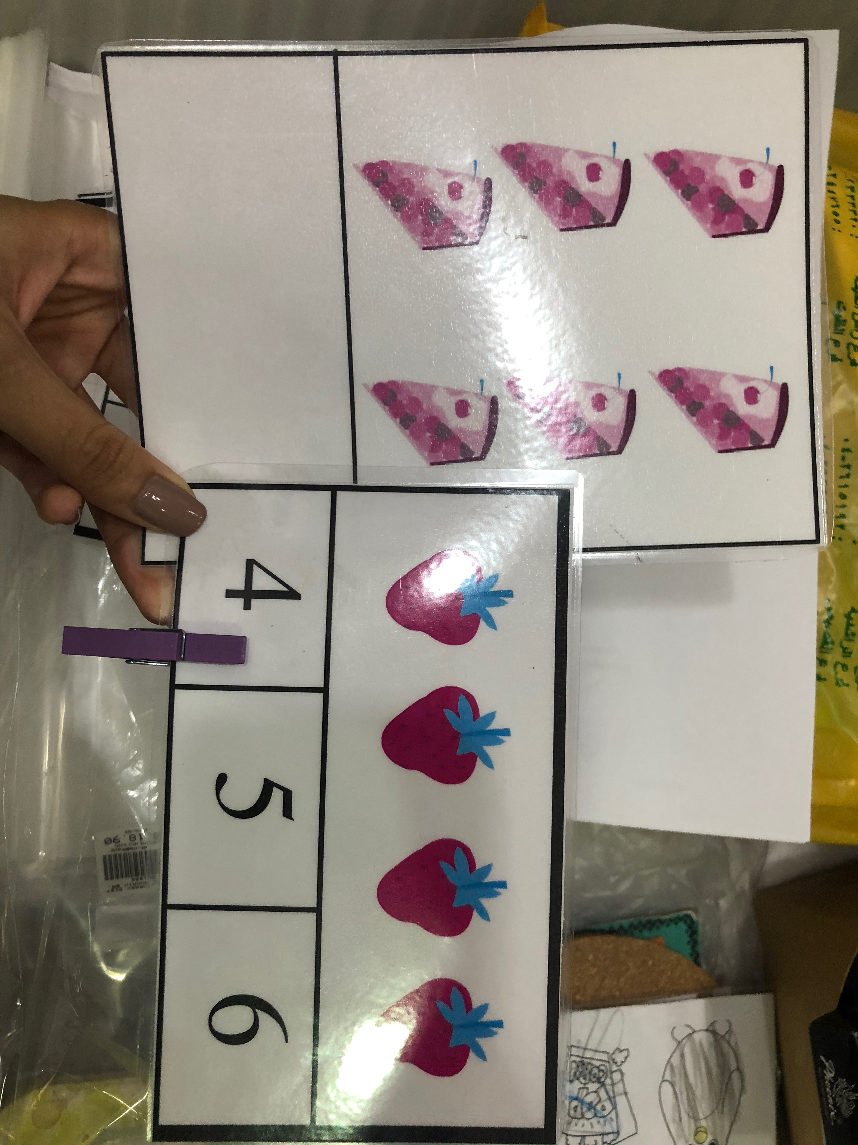
TP Competency | Planning for Learning
Action 2 | - To plan for a lesson I need to do lesson plans well. Before implementing any lesson I have to do a plan at least one day before.  - Use simple usable activities that suit children’s abilities, needs and within the time required to do the activity.  - Set learning objectives/outcomes that I want to achieve.  - Provide suitable materials for the whole lesson/week.  - Do weekly/daily plans, and ask the teacher to help me in medium-term and long-term plans.
Time frame | Within seven weeks.
Support needed | - The teacher can help me by taking pictures and videos of me implementing the lessons.  - The teacher can evaluate me.
How will you provide evidence of the success of the action | - I will use the documents of the lesson plans.  - Ask the teacher to evaluate my teaching through observations and taking notes, and using the evaluation sheet
Evidence  (After implementation) | Planning for lessons. Using specific and suitable learning outcomes to child’s needs. Use more activities rather than worksheets.
Reflection
(What happened because of this action?)

 | Improving my lessons plans was a goal for this semester teaching practice. In the previous semesters, I did many lesson plans that included differentiation activities for each level (emerging-developing-mastering) which was good to make an activity according to each child’s ability, but the problem is that in one lesson plan I had 3 or more learning outcomes which is hard to focus on each in one lesson because it is too broad. Now, I can make one lesson that includes the three levels with one or two learning outcomes. For example, students will be able to count and write numbers from 1-10. This learning outcome was suitable for the high and low level students. The high level students had cards with different pictures related to the story (the very hungry caterpillar) that was read in the circle time like apples, strawberries, cakes, and they have to count the things and write the number in the space. For the low level students, they also had cards of counting but they had three options underneath the pictures and they had to use the clip to hang it under the correct number. Another good thing is that the lesson plans times were specific and I applied the lesson on the time. My MST told me that the lesson plans that I did were detailed, has all the information about what the teacher is going to do and what the child is going to do, it also included the assessments that I want to do for children to assess their understanding. For the assessments I used two for all the lessons that I did during this semester teaching practice. The assessments are checklists and asking questions through the lesson. | Rationale / Justification  (At least 2 rationales/justifications needed + Academic Literature)
Goal 3 | Use formative assessments in my daily teaching | Rationale / Justification  (At least 2 rationales/justifications needed + Academic Literature)I want to improve the formative assessment during this teaching practice, because I didn’t use assessments before so I want to knoe more about doing assessments. Assessments will help me know about each child’ knowledge and level in learning. This will lead me to improve my teaching, modify my future lesson plans and provide suitable activities for each child. I chose formative assessments because it is more used in the kindergarten than the summative assessment and because formative assessment helps children improve in learning without grading their works (assessment for learning). According to Seth Wagner, “formative assessments allow us to adapt instruction based on results, making modifications and improvements that will produce immediate benefits for our students’ learning” (Wagner, 2015)
TP Competency | Assessment -
Action 3 | Use different strategies for formative assessments:  - Asking questions: asking children questions about the lesson will help me to know if children understood the lesson or not. For example, asking children what number is this? or how do we write letter S? and so on.  - Using thumbs up and thumbs down flashcards for the end of the lesson or even during the lesson. For example, asking them do you know what animals in this picture? And if they used thumb up it means they know the animal’s name and if it is thumb down it means they don’t know. At the end of the lesson the teacher can ask them did you understand the lesson? And they can use to say yes or no.  - Checklists are very beneficial and it makes us know about each child’s learning and knowledge of a lesson. Simple by asking the child a question like make the sound of letter K, if he/she knows the teacher will put mark on yes he/she knows and if he/she doesn’t know the teacher will put no.  - Observe students while doing activities and take notes.  - Document students’ works and review it at the end of the day.
Time frame | Within 8 weeks
Support needed | I will need my MST’s help in making checklists and asking students good questions.
How will you provide evidence of the success of the action | - Using the checklists.  - Taking pictures of students using flashcards  - Notes that are taken while observing students work during the class.
Evidence  (After implementation) | During this semester, I used checklists and asked questions through the lesson to check on children’s understanding. The checklist includes: the learning outcomes, the names of the students and numbers 1,2,3.  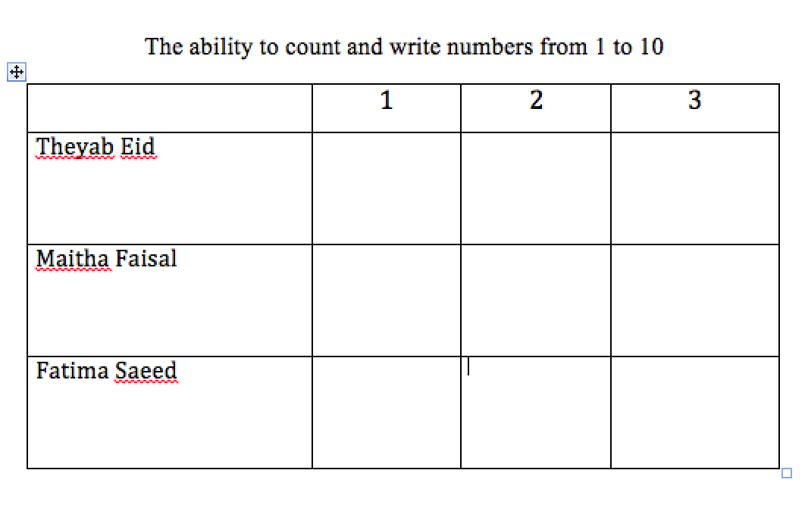
Reflection  (What happened because of this action?) | In this semester teaching practice, I used different formative assessments in each lesson. We have learned about using formative and summative assessments before but I haven’t tried anything except asking questions to check children’s understanding. Using formative assessments was part of our lessons and we had to do it. For the early childhood we have to use formative assessment, which is assessing for learning and it is not marked. In the kindergarten they use formative assessment everyday. The teacher has checklists displayed on the wall of the classroom, she use it everyday after doing the activities. Her checklist includes names of the students and numbers from 1 to 3, and she writes up what she wants to assess them on. For me, I used checklists while children are doing the activities, observe them and when the child is doing the activity correctly it means that he understood the activity and I tick on number 3. When the child knows how to some parts but not the whole activity it means he/she needs improvement in a specific thing in the activity, for example, I have a child that know how to count correctly but he don’t know the form of all the numbers, which means he needs improvement in recognizing the forms of all the numbers from 1-10, this student will get 2/3. For the students who don’t know how to do the activity, for example, a child who doesn’t know how to count and write numbers. This child needs more focus to improve his abilities in counting first then writing the numbers. Through the observations and checklists the teacher can know what the child needs to improve in and prepare activities based on this. I also asked different questions through the lessons o make sure that children understood the information. The questions that I asked are while and after reading each story and at the end of each lesson. For example when I read ‘brown bear, brown bear, what do you see?’ story, I was saying the names of ach animal in the beginning but when I read it for the second time, I read it as a question and children responded ‘I see a blue bird looking at me’, they were looking at the pictures and answering my question ‘what do you see?’. These questions to make sure that children know the colors and the names of each animal.

