Observation Task 4: Development of Early Writing Skills
Table 4: Development of Early Writing Skills
Developmental Writing Stage | Supporting Activities | Links to the ADEC Curriculum
3 – Strings of Letters | 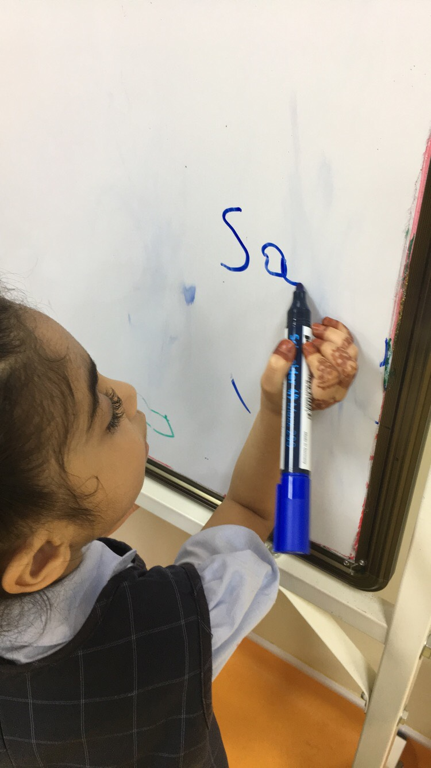  Writing letters on a white board using markers. | - Link sounds to letters, naming and sounding the letters of the alphabet.  - Hold the marker in a right way to help write the letter correctly.
 | 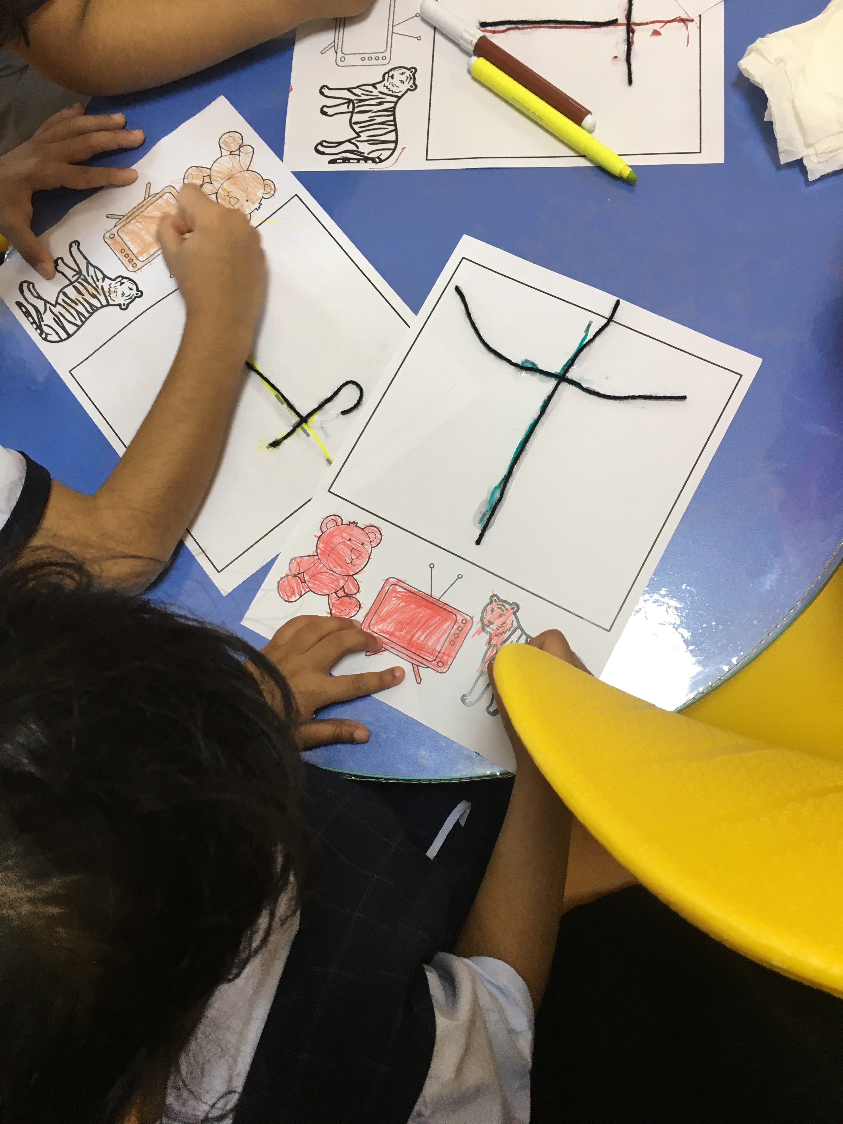  Write the letter using marker/pencil on a white paper and the use the glue to stick the thread on the written letter. | - Link sounds to letters, naming and sounding the letters of the alphabet.  - Use the marker or pencil, hold it effectively to write the letter correctly, and use the thread to form the letter.
Suggestions for the further development of early writing skills
- Use tracing cards to trace the letter then write it by themselves
- Use flashcards to form the letter in a right direction using their fingers.
- A homework worksheet to write the letter several times.

Reflections on Observation Task 4: Development of Early Writing Skills

- What are developmental writing stages the majority of the students in?

The majority of students are in the third level of writing, which is strings of letters. They can trace letters, write them, and form them using different materials such as thread and coloured papers.

- Describe and explain two (2) suggested strategies that the teacher can use to help the majority of the students within their developmental writing stage.
- The teacher can do more of craft activities using materials that children would love to use them such as beads, newspaper, cotton, spaghetti or anything that is related to the lesson.
- Extend the lesson using technology like iPad and computers that include apps and programs to help children write, name and make the sound of the letter.

