Observation Task 3: Teaching Shared/Guided Reading
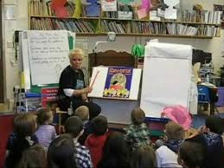
Focus: Identify the structure used by your MST while implementing a shared or guided reading lesson.

Objective: To encourage student teachers to identify and discuss the purpose of Shared or Guided reading and how it helps promote Concepts About Print (CAP) skills, phonemic awareness, letter knowledge and phonics.

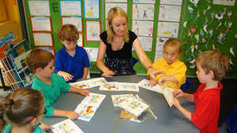
Procedure: Familiarize yourself with the Observation Table: Shared/Guided Reading. Identify the specific book and reading skills modeled by your MST and any skills that were demonstrated by the students.

Table 3: Teaching Shared/Guided Reading (Example)
The title of the book: Cats
Type of Reading (Shared or Guided): shared reading
What the teacher does | What the children do | Comments
- The teacher tells children the story title in a loud voice “cats” and pointing on it so children know that this is the title of the storybook.  - When the teacher reads each page, she points on the picture to make children absorb the information. She points on the cats and tigers body parts and name them “tail, eye, ears, teeth, fur”  - Choose a number of students to read the story to the students in the teacher’s place in a loud voice. | - Children repeat after the teacher the title of the storybook in a loud voice “cats”.  - Children repeat after the teacher and name the parts of a cat and tiger’ body.  - Students read the story in the front of their friends using teacher’s voice. | - There is a student her name is Ghala and she is an excellent student in the class. When the teacher asked her to read the story she read like her way and using her voice tones. Actually the teacher’s way in reading was good and easy for children to understand the story and reread it so that is why most of the children wanted to read the story to their friends.

Reflections on Observation Task 3: Teaching Shared/Guided Reading

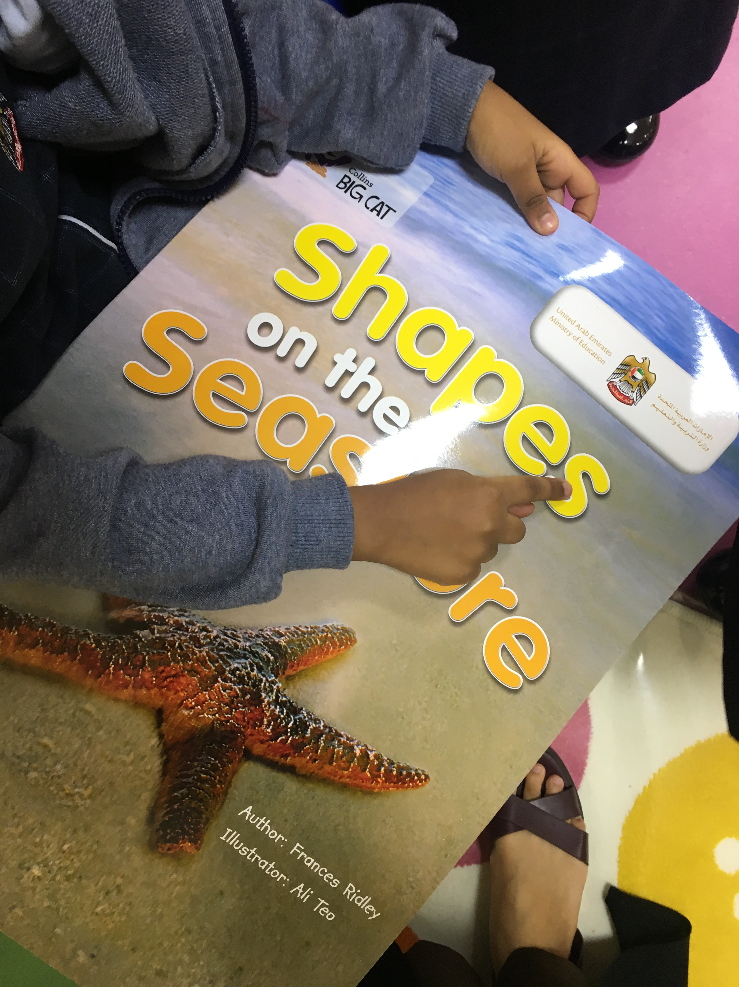
- Which concepts about print (CAP), phonological awareness, letter knowledge and or phonics did the teacher focus on?
The teacher focused on phonological awareness and letter knowledge while reading the story. She asked them about the letters they know in the story, point on them and make the sound of it.

- What did strategies/activities the teacher use to help the students understand the concept being taught?
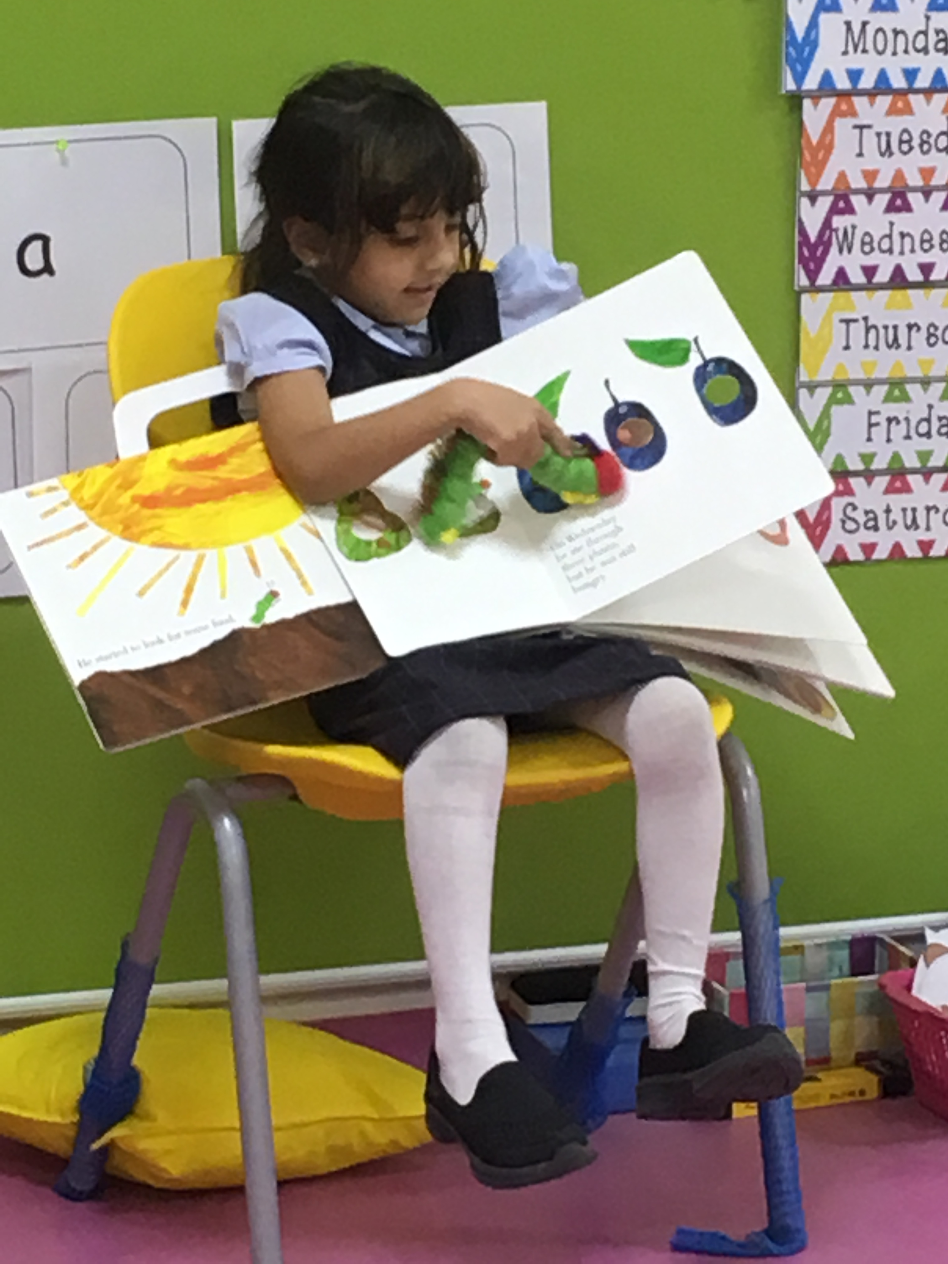
When the teacher read “the very hungry caterpillar” story she used the caterpillar puppet to help children understand the story. In every page there is a number of holes on the fruits that the caterpillar eats, so it attract children and motivate them read the story by themselves.

- Were there any initial/medial/final sounds, punctuation, sight words or word families that were covered during the lesson? If they were, select (a); if they were not, select (b).

- What was the purpose of teaching these concepts? Explain its importance.

Every week the teacher teaches the students a number of sight words (the, we, I, my, like, see) that are also included in story and help children to read it in the story not only on the board.

