Observation Task 1: Environmental Print in the Classroom

Table 1: Documenting Environmental Print
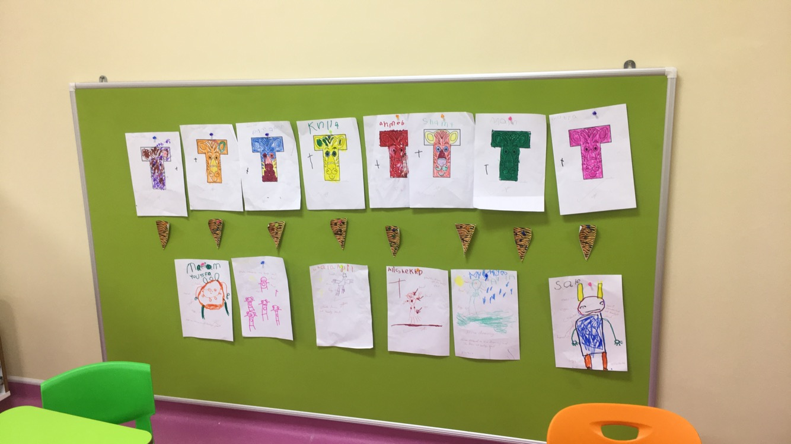  Examples of Environmental Print | Purpose | Ideas for further development
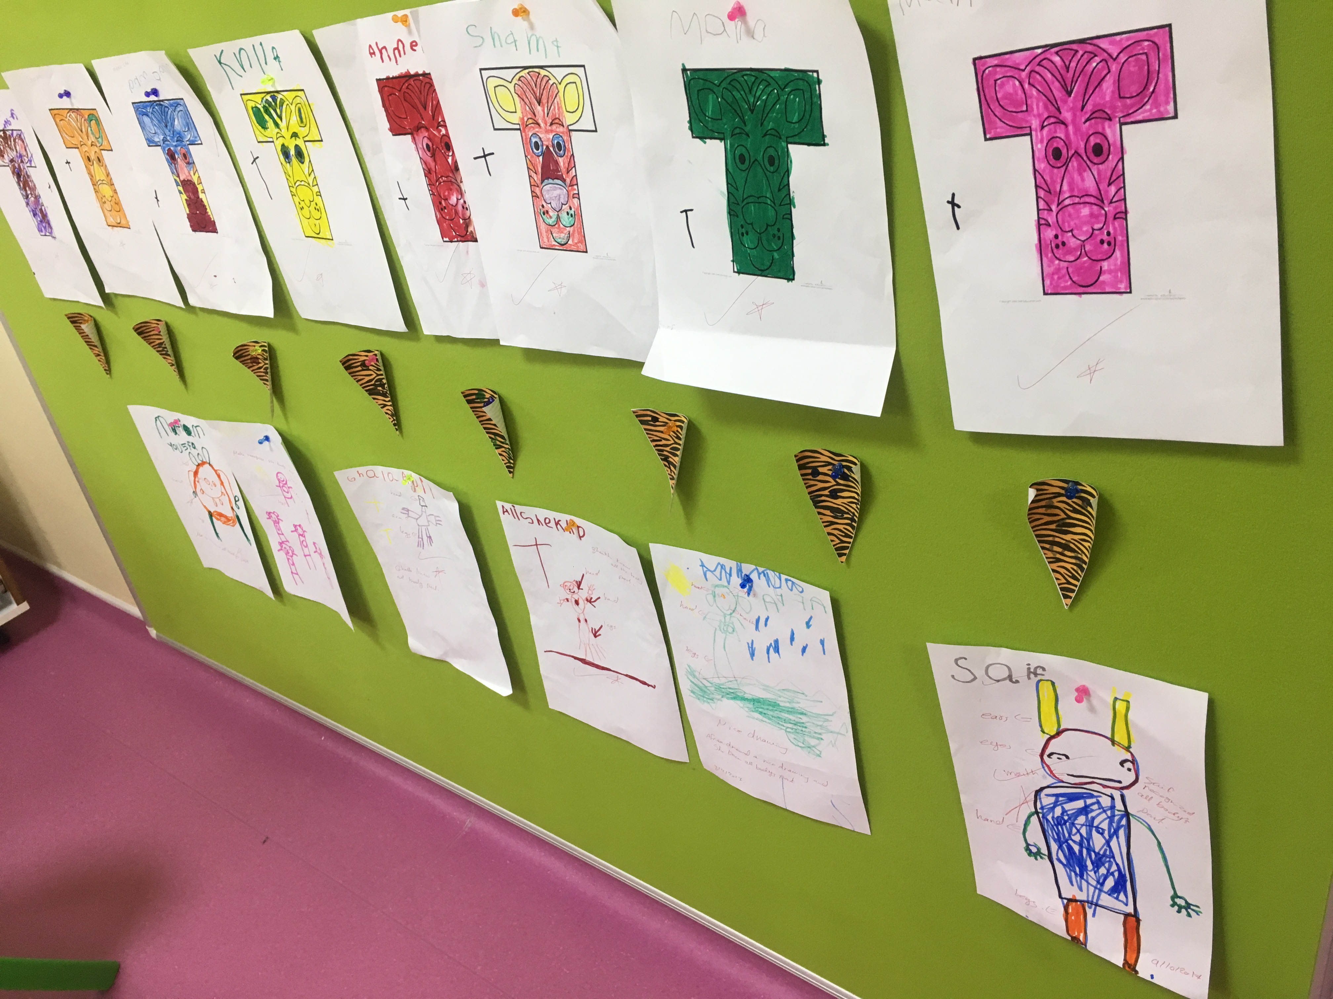  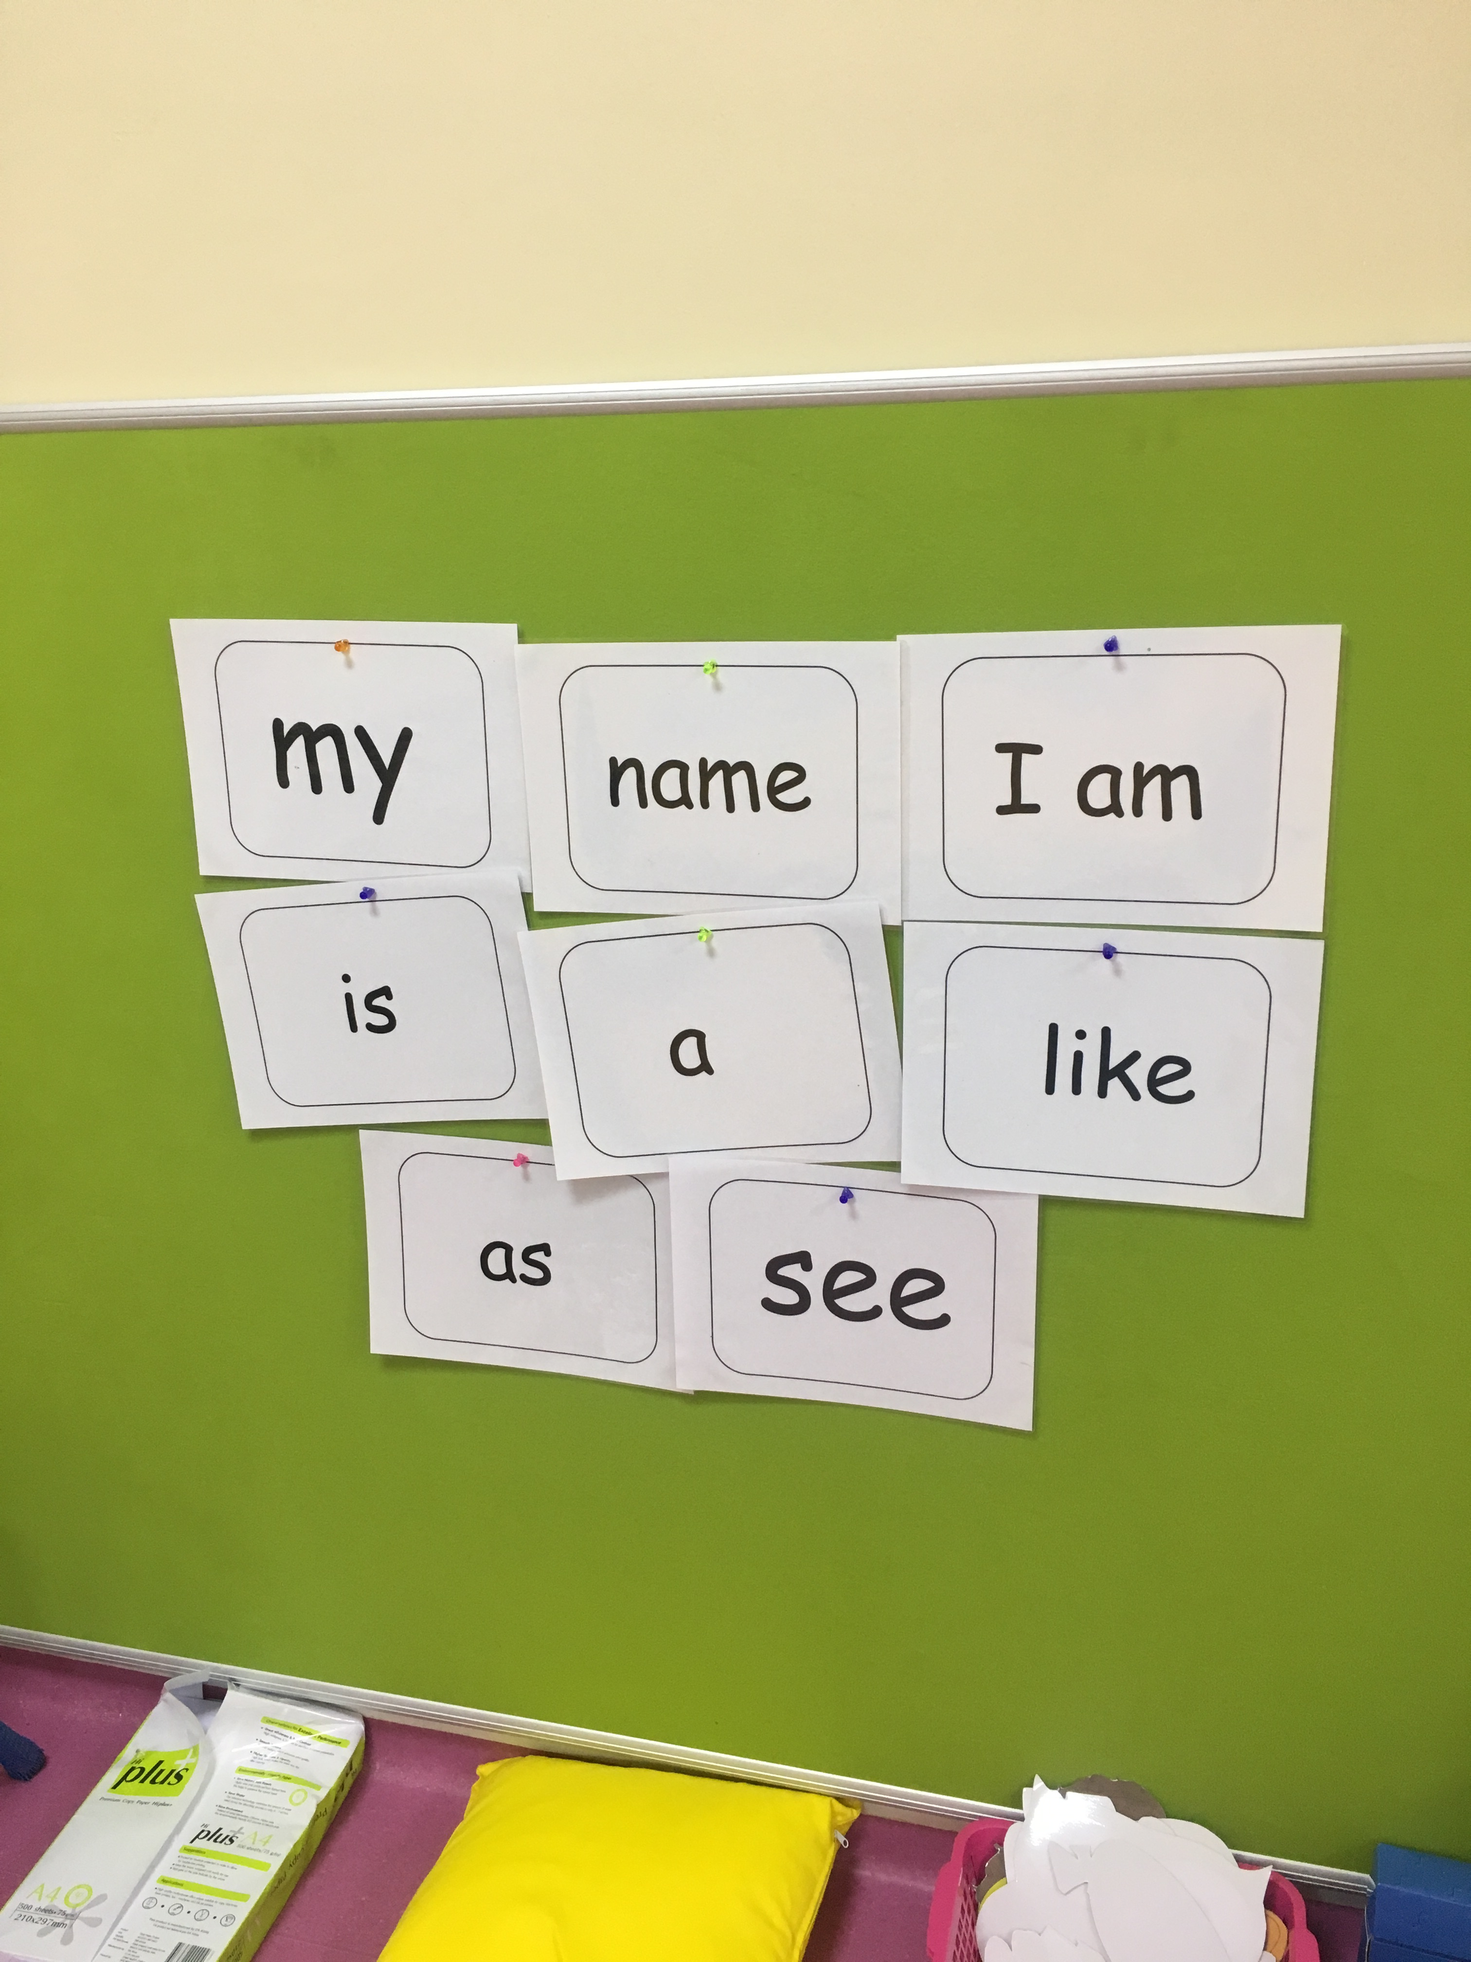 | The purpose of this environmental print is to allow children display their works in the English class and raise from their self-confidence every time they look at their work.  - On the top children’s designing the letter /t/.  - at the bottom children’s drawings of the body parts. | I suggest the teacher to make a board of each lesson, for example, providing pictures of tiger, tv and teddy for the letter /t/.
 | Remind children of the sight words. | Make it colorful, and include pictures  with each word to make it clear for children and relate the sight words to a picture and so they remember it.

Reflections on Observation Task 1: Environmental in the Classroom

Read the questions below and choose (1) one to respond to

- How does environmental print impact students’ language development, and their reading and writing abilities?
It helps them to read the sight words of the week and review it by themselves every time they see the board.
- How do students of different reading levels use environmental print?
The pictures that are set beside the words on the board help children recognize the words.

- How does awareness of environmental print impact how students view themselves as readers?
The environmental print can relate to the real life and things children can do at home. For example, the board in the class is about the shapes and their names so children can relate the shapes they see on the board to things they see at home like circle=clock, square=tv, etc. Parents can help children at home to recognize the shapes by giving them things that have the shape they learned about in the kindergarten.

