

-Instat message: Reach parents quickly and privately with direct messages.

-Announcements: If the teacher have an important update he send a blast to every parent.

-Photos: Parents love seeing these moments and what's happening in the class by photos.

--Read Receipts: know when parents read the message.

**Classdojo**

Disadvantages:

-Some students don’t like technology and don't know how to use it.

-you can't access without Internet.

-Not all the behaviors are written in the feedback bottom.

Advantages:

-Free app, works on iOS, Android and any computer.

-Simple to use, so the students feel comfortable.

-Students can make helpful conversations with teachers, if they need help while they doing their individual work at home.

-Reinvent classroom by bringing teacher, student and parents together.

-Communication platform to motivate students by encouraging them.

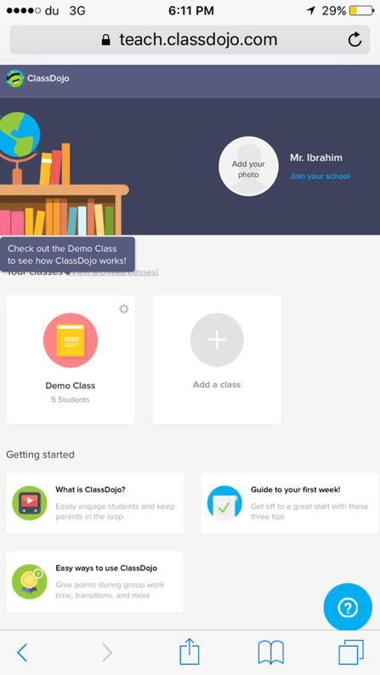

**How do we use it?**

**It's an easy way for teachers, students and parents to communicate and share their best moments.**

**Presentation/ information sheet on Classdojo site**

**Section 1**

**Nada Khalel – Hiya Ibrahim**

**Teacher: Nadya Moosa**