Lesson Plan Template 2
Date | Subject | Number of students |  |  | Grade
1-11-2016 | Math  (shapes, pattern) | 25 |  |  | KG 2  5 years old
Personal Aims (What do YOU need to work on in order grow professionally?)
I will work on:
- Classroom management
- Confidence in teaching

Learning Outcomes:  (Link to the ADEC / MOE K-5 curriculum document) |  |  | Materials
Students will be able to:  - Copy simple repeating patterns. |  |  | - Computer  - Projector  - Smart board  - Presentation to show types of patterns  - Worksheets  - White paper  - Colors  - Cubes  - Blocks
Lesson Introduction
Whole group activity: Time 15 minutes  Opening/Introduction: (Bullet points)  What will you do in order to introduce the concept to the students?  - Present a presentation to show them different types of patterns.  - Show children colorful cubes and create a simple pattern in front of them.  Active Engagement: (Bullet points)  After you’ve modeled the concept, what activity will you have the students perform while on the carpet to ensure that they understand it?  - Choose several students to create their own pattern using the cubes.  Link: (Bullet points)  Remind the students in kid friendly language how they can apply what they did whole group in their independent learning centers  - High level:  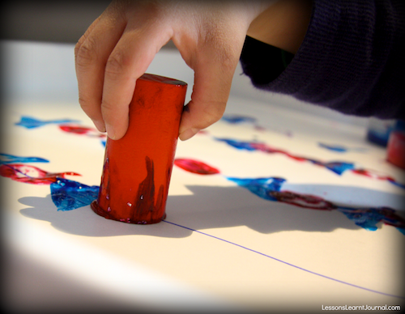  Children will have A4 papers, colors and spongy shapes. They will put the shapes in the colors and print it on the papers to create the pattern that they like.  - Medium level:  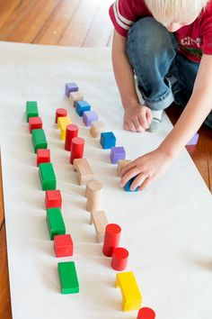  In this level, children will use the blocks to create their own pattern.  - Low level:  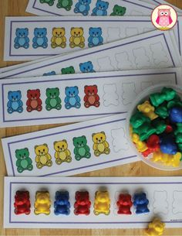  Children will get a worksheet that has pictures of colorful bears, and 3D colorful bears. They will see the first picture of bear with which color, then they will choose the 3D bear with the right color to put it on the first picture, and then they complete the pattern. That means they already have the pattern on the paper, they will only take the bear with the right color and put it on the picture. |  |  | Question (Blooms Taxonomy)  Remembering (low level):  Before starting the lesson, the teacher will show children the shapes and ask them: What are these shapes? Which color is this shape?  Understanding (low level):  A presentation that has pictures of different patterns to introduce them to the concept.  Applying (low level):  The teacher will use the colorful cubes to create a pattern, then she will choose some students to create in front of their friends their patterns.  Analyzing (high level):  The teacher will give each child a bag with colorful keys to create their pattern.  Evaluating (high level):  I will assess children understanding after they finish the differentiated activities.
Learning Center Resources or Materials
Learning Center 1  - Presentation  - Colorful cubes  - Colorful shapes  - Colorful keys | Learning Center 2  Art center – High level:  - Colors  - White papers  - Sponge shapes | Learning Center 3  Block center –Medium level:  - Cubes | Learning Center 2  On the tables – low level:  - Worksheet  - Colorful bears

Small Group Learning Centers: Time 10 minutes
Learning Center 1:  On the carpet  - Children will sit on the carpet (circle time). First, the teacher will show them shapes with different colors and ask them: What is this shape? What are the colors of these shapes?  as an engagement of the lesson.  - After that, the teacher will present a presentation that has pictures of different types of patterns to introduce them to the new concept.  - The teacher will use the colorful cubes to create a pattern, and then she will choose some students to create their patterns in front of their friends.  Learning Center 3:  Block center –Medium level:  Medium level:  In this center, children with medium level will sit in the block center and the teacher will ask them to create their own pattern using colorful cubes. |  |  |  | Learning Center 2:  Art center – High level:  High level:  Children with high level will sit in the art center and they will have A4 papers, colors and spongy shapes.  The teacher will put for them some colors in the plate. Children will take the spongy shape, place it in the plate to be colored, then they will print it on the paper. They will do the same thing to create their own pattern with different shapes and colors.
Learning Center 3:
On the tables – low level:
Children with low level will sit on the tables. They will have a very simple activity. They will have a worksheet that has six pictures of colorful bears in a certain pattern. Children will use the colorful 3D bears to place it on the right picture of bear on the worksheet e.g. if the first picture in the worksheet is a yellow bear then the child will choose a yellow bear from the box and place it on the picture of the yellow bear, then he do the same to complete the pattern.

Closing activity: Time: 5 minutes

Allow children time to discuss how what they did during their learning centers and how it relates to the lesson outcome

“Remember that….” (restate outcome using kid friendly language)
After doing the different levels activities, children will sit on the carpet and the teacher will ask them:
Remember that we learned a new lesson today, what is it?
What did you do in the centers?

Assessment for Learning: How will you determine if the students understood the learning outcome? What evidence will you show to prove this?

I will assess children understanding while they are doing the activities in the centers.

