Lesson Plan Template
Professional Development Plan
(What do YOU need to work on in order to grow professionally?)
- Choose and describe an aspect from a teaching competency that you need to work on (Goal)
Behaviour Management - Managing students’ behaviour in the classroom
- Describe what you will do to help achieve your goal (Strategies Used)
I will try to use different strategies. For example, use the bell to grab children’s attention when they lose it, use the reward system to encourage good behaviour and praise the, use classroom rules in the beginning of the circle time, and for children who make noise or bother their friends I will use verbal words for example, Ghaith don’t hit your friends or you’ll not get a star today!

- Describe how you can tell if you’re achieving your goal (Evidence)
I will ask my MST to record some videos of me during the class, and to do observations and write notes about what I did.
Grade Level:  KG2 / 7 |  | Subject:  English \ Story |  | Learning Outcome (ADEC code and words):  Students will be able to:  - Demonstrate an understanding of how to plant in the correct sequence.
Resources (what materials/equipment will you and the students use? Be specific)  - Storybook: The Tiny Seed.  - Laptop.  - Colouring, naming and tracing the needs of a plant activity worksheet.  - Numbering and ordering stages activity worksheet.  - Pencils  - colours  - Tambourine  - Plant  - Flashcards - Poster |  |  | Preparation (what do you need to make or check before class?)  Check on the computer that it’s working.  Check that all materials are ready and in their places.  Key vocabulary  - Pot  - Soil  - Bean  - Seed  - Sun  - Water – watering  - Plant
Whole  Time: 15-20 min | Introduction (warmer activity + teacher active engagement)  Saying good morning, singing the days of the week song and doing head shoulders knees and toes song and actions.  Before reading:  Show children a plant and ask them what is this? this is a plant. what do we take from the plants? We can take food: fruit, vegetables, and we can see a flower in the plant.  Show them a poster of the plant’s needs: 1.pot 2.soil 3.seed 4.water 5.sun 6.then it becomes a plant.  Use the flashcards, name the things, and children will repeat after the teacher.  While reading:  Story title: The Tiny Seed.  Ask children to sit in the middle.  The teacher will show children the cover page, ask children: what do you see in the cover?, read the title and point on it.  Children will repeat after the teacher the title of the story.  The teacher will read the story in simple words, and ask children in between: what is this? this is seed, where did it go? on the mountain, under the water, in the soil. What did the seed become? It became a big flower big and big then it became a giant flower.  After reading:  Ask children:  Did you like the story?  What did you see in the story?  Where did the seeds go?  What did the seed become?  Did you like the very big flower?
15 min | Independent Experience (small group activity 1)  High level students:  The teacher is going to show the students small cards that have pictures of a plant’s needs.  Children will order the cards and glue it on a white paper in order from number 1 to 6.
Independent Experience (small group activity 2)
Low level students:
The teacher will show them the activity and ask them to trace the words and colour the pictures.
Children are going to trace the words, colour the pictures, and name the needs of a plant in order.
Closing  Time:10 min | Check their understanding – summarize – show what have they done  At the end, the teacher is going to review the flashcards of a plant’s needs and children are going to name them.  The teacher is gong to review the poster of a plant’s, point on the each picture, and students are going to name the needs.  The teacher is going to put the flashcards on the board (not in order) and ask a number of students one by one to help her in ordering the needs of a plant.  The teacher is going to bring their plantings that they did on Sunday to check if the seed grew up to a plant.
Assessment
Asking questions through the lesson.
Use a checklist during activities time for ordering a plant’s needs.

Activity 1

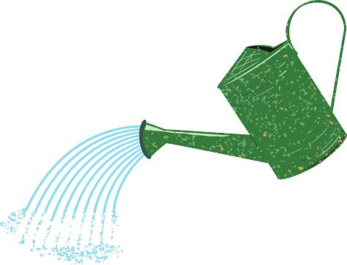
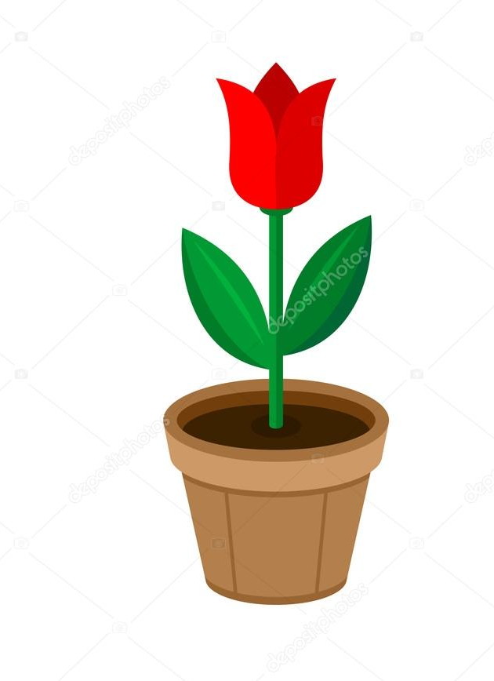
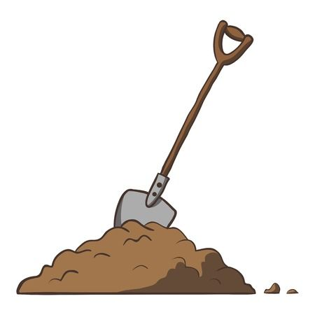
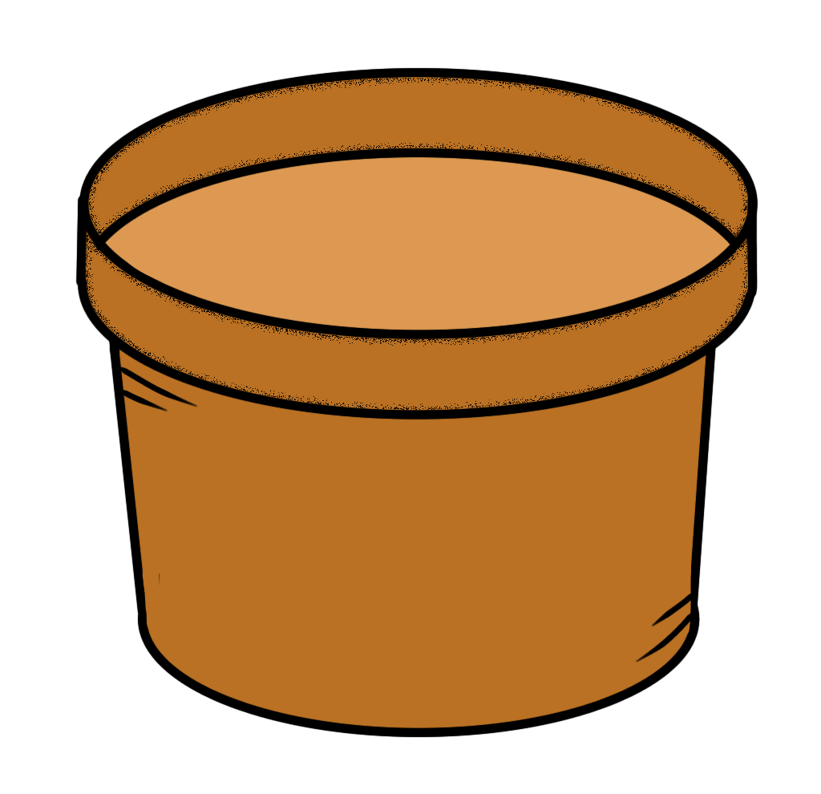
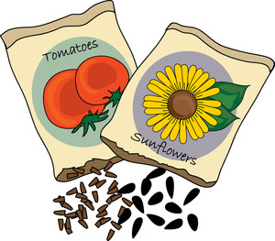
plant
pot
soil
seed
sun
water

