Lesson Plan
Name: Nada Khalil Bin Took

Professional Development Plan
(What do YOU need to work on to grow professionally?)

- Choose and describe an aspect from a teaching competency that you need to work on (Goal)
This semester, I want to work on classroom management: time management and behaviour management.

- Describe what you will do to help achieve your goal (Strategies Used)
- Time management: managing the time, doing the activities in the specified time by using a timer so when children listen to it they stop the activity and clean up the place.
- Behaviour management: by rewarding the good students and give them a gift. Make an eye contact with the students who misbehave or change their places.
- Describe how you can tell if you’re achieving your goal (Evidence)
Asking my MST to take pictures or video. Also her notes about my teaching will be helpful.
Grade Level:  KG2 |  | Subject:  Literacy – Story (science) |  | Learning Outcome (ADEC code and words):  Students will be able to:  - Recognize the letters that they have learned in the story.  - Identify shapes and differentiate between them  - Identify things/sea-animals and name them.
Resources (what materials/equipment will you and the students use? Be specific)  Colours  White A3 papers each with a sea animal.  Small pictures of seashore things to colour  Glues  Laminated coloured shapes with a big size (to jump on) |  |  | Preparation (what do you need to make or check before class?)  To check on the computer and data-show (projector), the materials are all ready and in their places.  Key vocabulary  Starfish - Star  Jellyfish - Circle  Pebble - Oval  Seashell - Spiral  Razorshell - Rectangle
Whole  Time: 15 min | Introduction (warmer activity + teacher active engagement):  Show children the front cover of the story and ask them: what do you see here?  Tell them about the front cover, back cover, illustrator and author  Reading the story using facial expressions and voice variations.
Time: 15 min | Independent Experience (small group activity)  Group 1/ science activity: pictures of sea animals/things: jellyfish, pebble, starfish and seashell stuck on each wall of the class and a group of student will be given small pictures of two things and they will name what is it, colour it, search for the same picture on each wall and stick it under the big picture.  Group 2/ math activity: the shapes that children saw in the story will be on the floor and the teacher will do the activity with a group of students. The activity is to jump on the shape that the teacher tells. For example: if the teacher said “jump on the circle” so the child will search for the circle and jump on it.  Group 3/ literacy activity: a group of children will try to figure out the letters they learned (s,a,t,p) and count how many times they saw and write it on a paper.
Closing  Time: 5 min | - Ask a child from each group to tell his friends about the activity they did.  - Ask a child to re-read the story to the class.
Assessment
- Ask children to name the shapes and the things they saw in the story.

This lesson is for level 2 in the kindergarten. The learning outcome that I used for teaching this lesson was; students will be able to recognize the letters that they have learned in the story, identify shapes and differentiate between them, identify things/sea-animals and name them.
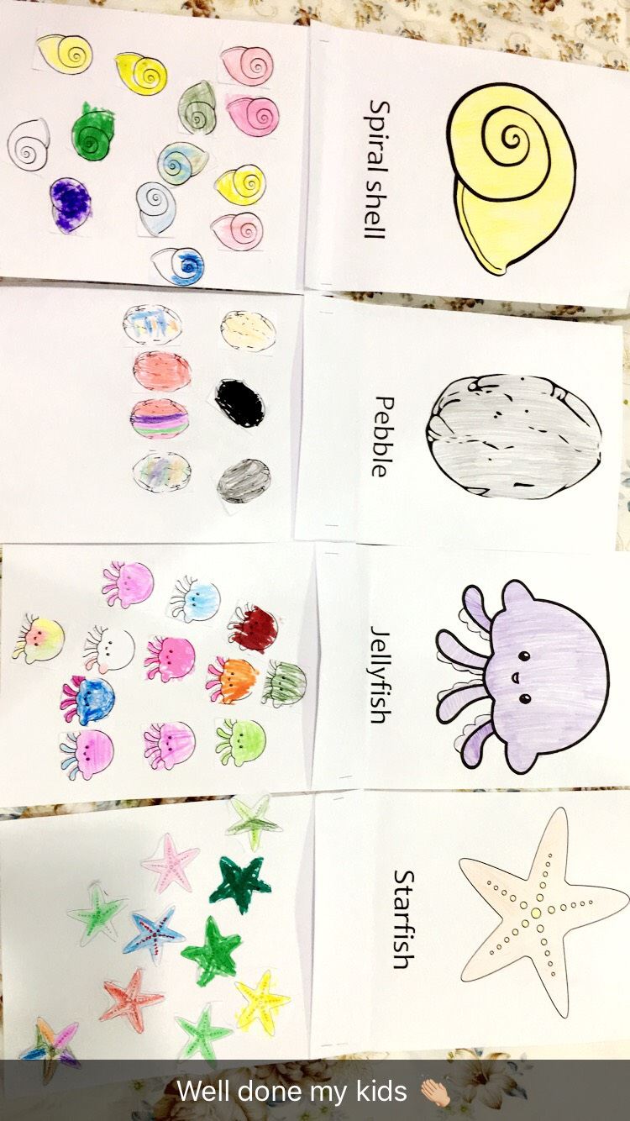
This lesson was different than the other lessons I taught. Actually it wasn’t a lesson it was in the story time but I used different activities. Children love to listen to a story and reread it after the teacher. In this story children were engaged because I used different voice tones to grab their attention and the colors of the story were attractive. The three activities that I used are for science, math and literacy. In the math activity, students jumped on the shapes that I asked them to jump on. For example, when I say "jump on the circle" the student jumps on the circle and if a student made a mistake his/her friends help him/her to jump on the right shape. In the science activity, students were happy with the activity because they have to color the thing, search for the big picture in the class and stick the small picture under it. In the literacy activity, students read the story by themselves in the reading corner and they identified the letters they have learned in the previous weeks (s,a,t,p).The lesson went well and children enjoyed it. I just need to improve time management because the story time is short.
