Lesson Plan Template 2
Name: Nada Khalil Bin Took

Personal Aims (What do YOU need to work on in order to grow professionally?
Classroom management: behaviour and time management.

Grade Level:  KG2b |  | Subject:  English – Letter h. |  | Learning Outcome (School code and words):  - Pronounce, write and identify the words that start with the letter h.
Resources (what materials/equipment will you and the students use? Be specific)  Smart board  Computer  Colors  Worksheets for the three levels  Projector  Small borads  A4 papers with letter h  Stickers  Stamps  Pencils  Song about the letter h:  https://www.youtube.com/watch?v=xRQbrDwmDKk  Online games:  https://www.youtube.com/watch?v=Lh5uu9ELqDM |  |  | Preparation (what do you need to make or check before class?)  Check on:  - Projector  - Computer  - Smart-board.  Key vocabulary  Hen  House  Helicopter  Hat  Hot
Whole  Time: 15 min | Introduction (warmer activity + teacher introduction/demonstration of small group activities)  - Welcoming students and doing the day and the date.  - Playing a song about the letter h.
Small  Time: 10- 15 min | Active Engagement (group working with the teacher)  - Show students how to write the letter p.  - Write the letter h in the air, on the ground and on the small boards
Independent Experience (small group activity 1) Low level
- Activity tracing the letter h and colouring pictures.
Independent Experience (small group activity 2) Middle level
- Matching the letter h with the suitable picture.
Independent Experience (small group activity 3) High level
- Write the missing letter h in the gap.
Explain how you are going to differentiate:
- Group 1 (low level):
Children in the low level group will do an activity worksheet to trace the letter h and color the pictures that starts with letter h.
- Group 2 (middle level):
Children in the middle level group will have a worksheet to to match the letter h with picture that starts with letter h.
- Group 3 (high level):
Children in the high level group will do an activity to write the missing letter h in the gap with coloring pictures.
Whole  Time: 10 – 15 min | Closing:  A craft activity to design the letter h on an A4 paper using stickers, stamps, or by sketching.
Assessment
An online game to assess students’ understanding. The online game is about showing each child three pictures and he/she will tap on the picture that starts with letter h.

Hand craft activity for the letter h:

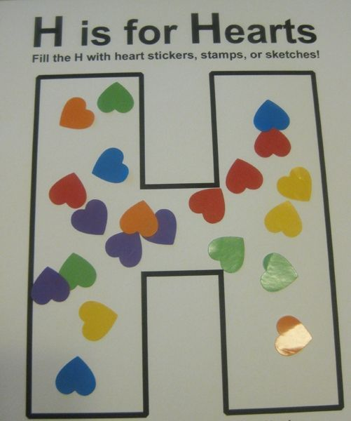

Reflection 2:

The lesson was for KG2. It was an English lesson about the letter h. The goal of this lesson was to let children pronounce, write and identify the words that start with the letter h. I liked how children were well behaved and active during this lesson. They did well in all the activities, and they were happy doing the handcraft activity at the end of lesson, which is designing the letter h using stickers. Children also benefit from this lesson a lot. They knew new words like: hen, hat and helicopter. In my opinion the lesson was successful because I achieved the lesson objectives. Also, I used different activities in this lesson, which was fun. At the end, I think that I need to learn more about managing the bad behavior.

