Lesson Plan Template
Professional Development Plan
(What do YOU need to work on in order to grow professionally?)
- Choose and describe an aspect from a teaching competency that you need to work on (Goal)
Behaviour Management - Managing students’ behaviour in the classroom
- Describe what you will do to help achieve your goal (Strategies Used)
I will try to use different strategies. For example, use the bell to grab children’s attention when they lose it, use the reward system to encourage good behaviour and praise the, use classroom rules in the beginning of the circle time, and for children who make noise or bother their friends I will use verbal words for example, Ghaith don’t hit your friends or you’ll not get a star today!

- Describe how you can tell if you’re achieving your goal (Evidence)
I will ask my MST to record some videos of me during the class, and to do observations and write notes about what I did.
Grade Level:  KG2 / 7 |  | Subject:  English \Letter Tt |  | Learning Outcome (ADEC code and words):  - Students will be able to recognise the sounds of the previous letters and words start with it.  - Students will be able to identify letter t.  - Students will be able identify how does letter t looks and write it.  - Students will be able to name pictures of things start with letter t: tiger, TV, teddy.
Resources (what materials/equipment will you and the students use? Be specific)  - Two boxes  - Flashcards of letters, s a t  - Computer and projector  - Worksheets  - Pencils  - colors |  |  | Preparation (what do you need to make or check before class?)  To check on the computer and projector if its working.  Check that all materials are ready and in the place.  Key vocabulary  - Tiger - Train  - Table  - TV  - Teddy
Whole  Time: 15-20 min | Introduction (warmer activity + teacher active engagement)  After saying good morning, singing the days of the week and months of the year songs, the teacher is going to engage the students to the lesson through the song of sounds. The teacher will do the actions with children and sing with them.  - The teacher will make a review for the previous sounds s and a by showing the picture and ask them: what is this? it start with what?  - Show students a picture of tiger and ask students, what is the name of this animal? It is tiger!, tiger start with what? It starts with t. t t tiger. And show them how does it look like.  - Show children the other flashcards of letter t: TV, teddy.  - Ask children to make the sound of letter t.  - Ask children to write the letter on the air.  Ask children to name the flashcards. What is this? it start with what? (Formative assessment)
15 min | Independent Experience (small group activity 1)  High level:  The teacher will ask students of this group to write the letter /t/ in the box, use the thread to make the letter (trace) on the /t/ that they have wrote. Colouring the pictures.  Use checklist to check their abilities of writing the letter and trace it using thread. (Formative assessment)
Independent Experience (small group activity 2)
Middle:
The teacher will ask students of this group to trace the letter /t/, use the tread to make the letter /t/ again on the t they have traced. Coloring the pictures.
Use checklist to check their abilities of tracing the letter and trace it using thread. (Formative assessment)

Independent Experience (small group activity 3)
Low:
The teacher will ask students of this group to design the letter the /t/ and color the pictures of thing start with t.
Use checklist to check their abilities of placing the colored papers inside the letter t and their ability to recognize things start with t and color it. (Formative assessment)

Closing  Time: min 5 | Check their understanding – summarize – show what have they done  Use two boxes. One box the letter t is written on it and the other one has no letter on it. Place flashcards on the floor on the pitures side. Ask a number of students one by one to choose a picture, name it, and ask them which letter does it start. If it is t, the child will put it inside t box, if it is not the child will put in the other box with no letter. Then the teacher will show children the flashcards in each box and name the pictures with children.  Ask students to rename the pictures of the flashcards of letters: t,s,a. Ask students what is this letter? by showing them letter t and what is the sound?. Ask students: how do we write letter t? let’s write it on the air. (Formative assessment)
Assessment
Asking questions through the lesson.

High

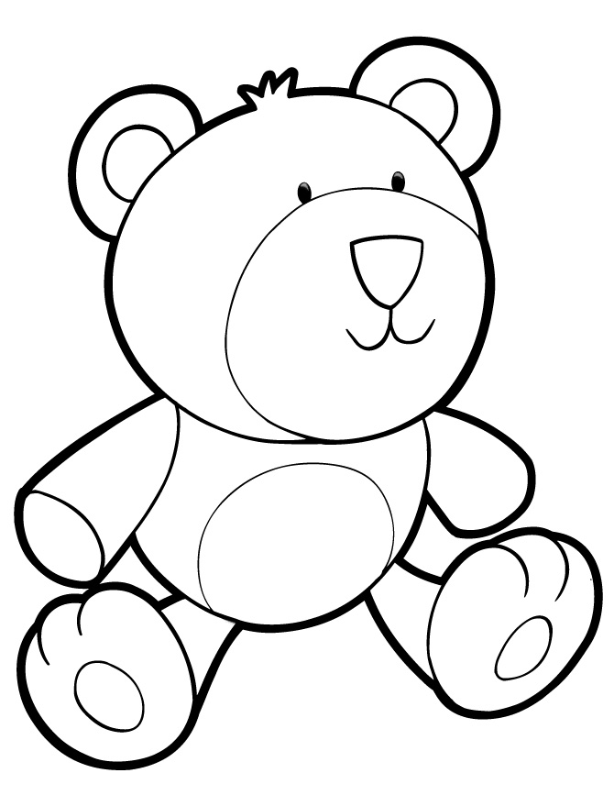

Low
Middle

