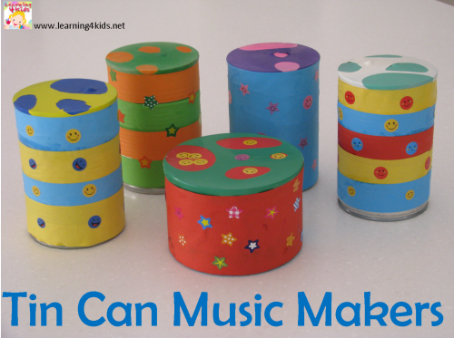

**Websites:**

1. Music Develops Children’s Social and Emotional Skills. (2015, April 4). Retrieved December 4, 2015, from <http://raisingsmallsouls.com/music-develops-childrens-social-and-emotional-skills/>
2. Pica, R. (2008). Unlocking Children's Creativity through Movement and Music. Retrieved December 4, 2015, from <http://www.earlychildhoodnews.com/earlychildhood/article_view.aspx?ArticleID=261>

##### **References**

1

## Nada Khalil

## H00329534

## 12B10ED01

## Ms. Antoinette Wiseman

The musical instruments are children toys for both boys and girls. They are useful way to entertain children, and develop them in different domains at the same time.

**“ Easy to create**

**Fun to play ”**

##### **My Musical Instruments**

**Books:**

1. Erikson, E. (1994). *Identity and the Life Cycle*. New York: Young Man Luther.
2. Piaget, J. (1969). *The Psychology of the Child* (H. Weaver, Trans.). New York: Basic Books.

6

##### **Theorists:**

- According to **Erik Erikson’s** social and emotional development stages. The musical instruments are designed to develop the relationship between the children. Sharing these toys will develop the social side. Also it develops the emotional side by making child active and motivation with playing with these instruments.

- **Piaget** said that children think different than adults. They learn by having new experiences in their life. According to his cognitive development stages. The musical toys were designed with different sounds so children can try all the instruments and know the differences between them. Also, using the instruments from the first time will be a new experience to them, so using it continuously will encourage their minds to absorb the different sounds and remember it.

5