Coursework Report- Piaget
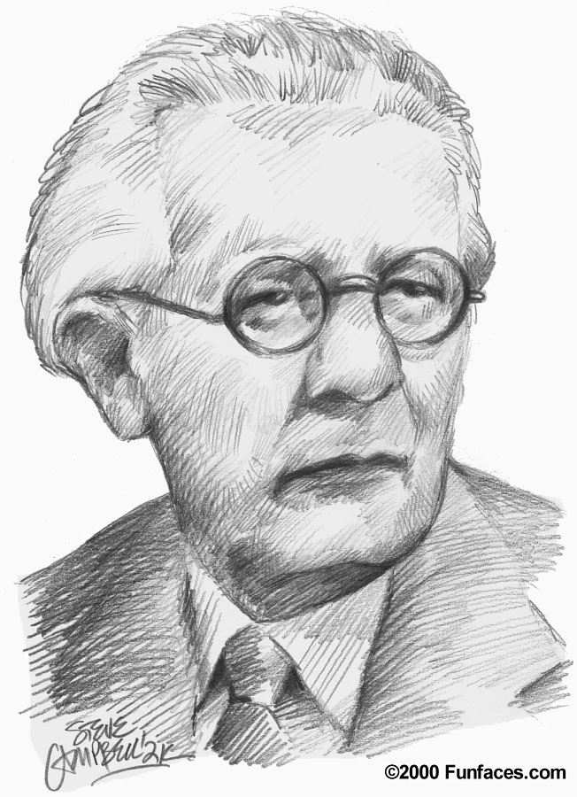

Name: Nada Khalil BinTook
ID: h00329524
Section:

Course Code: EDU 1003
Course Name: introduction to theories of learning 1a
Course Teacher: Antoinette Wiseman

Introduction:

Jean Piaget was born on August 9, 1896, in Switzerland and died in 1980. He was his parents, first child. At age 11, he wrote a short notice about albino sparrow. In 1921, he married Valentine. When he attended to Zurich University, he developed a deeper interest in psychoanalysis. Piaget's theory includes stages of development and cognitive stages.

Piaget’s theory:

In this report, I will talk about Piaget’s theory that includes the stages of development and cognitive stages.

Stages of development:
Piaget’s four stages of cognitive development are:

- The sensorimotor stage. Birth to 2 years
- The preoperational stage. 2 to about age 7
- The concrete operational stage. 7 to 11
- The formal operational stage. Adolescence and spans into adulthood.

1.Sensorimotor. ( birth to 2 years )

During this stage, infants and toddlers knowledge obtain through sensory experiences and touching objects. Piaget’s observation of his daughter and nephew affected his idea of this stage. At this point in development, a child's intelligence consists of their basic motor and sensory explorations of the world. At the age of 7 to 9 months, infants begin to realize that an object exists even if it can no longer be seen. At the end of sensorimotor toddlers reach another important skill (language development).

2.Preoperational. ( 2 to about 7 )

At this stage, children can think more about things. Their language improves and becomes more developed. They are improved in imagination and memory. Kids in this age learn through pretend play. But they struggle understanding the ideal of constancy.

3.Concrete operational. (7 to 11)

Children at this age begin to think more logically, but their thinking can also be stiff. Kids in this age become less selfish and start thinking about others feelings and what they might think. Kids also in this age begin to understand that their thoughts are different and unique.

4.Formal operational stage.
(Adolescence and spans into adulthood)

The final stage of Piaget's theory involves an increase in logic, the ability to use deductive reasoning, and an understanding of abstract ideas. At this age people can find solutions to their problems and think more scientifically about the world around them.

What are the cognitive processes?

1.Scheme
2. Assimilation
3. Accommodation
4. Equilibration

Observation task:

1. The experiment explanation

In this experiment, I observed many things. I did this experiment in my home. First, the two children were active and motivated for the experiment. I choose for this experiment Hamad 11 years old and Shouq 7 years old. I brought three different shapes of glasses, two have the same shape, and one is different ( long glass). I pour the same quantity of water into the two same shape glasses; then I asked both of them if they are different or the same. Both of them answered the same answer. After that, I pour water from one of the two same shape glasses into the long glass. Then I asked them again which one has more water. In this question, each of them answered a different answer. The little girl was shocked when I pour the water in the long glass. She thought that when we pour water from a small glass to a long glass, the water increase. I observed that the seven ages child judge on the shape, but the 11 years old child knows that the shapes are different, but the sizes are the same. I took four photos for this experiment. Two for the girl (7 years) and two for the boy (11 years).

2. The experiment report:

I did an experiment with two kids (Hamad 11 years and Shouq 7 years). The experiment was bringing three glasses (two has the same size and quantity of water and one long empty glass). I asked them questions and why did they choose this answer. In this report, I will compare between the two kids.

Here, I will talk about my experiment with Shouq (the girl in age 7). I put in front of her two small glasses with the same quantity of water and long empty glass. First, I asked her which one of them has more water? She said that they are the same. Second, I pour one small glass of water into the long glass, and then I asked her which one is more ? or they have the same and why? She answered that the long glass has more water because it is long, so it has more water than the small glass. She was active and sure about her answer.

Now, my experiment with Hamad (the boy in age 11 ) is different than Shouq. I started by asking him about the two same glasses if they are different or the same, he said that they are the same. Then I pour one of them into a long glass, and I asked him which one has more, or they have the same quantity and why? His answer was “ the two glasses has the same quantity of water, but they have different shapes, when you pour the water in a different glass shape the water took the glass shape but the quantity doesn’t increase or decrease, it is just the same”.

At the end. I think that Piaget’s theory will help teachers in their direction of students learning because Piaget’s theory agrees with most people experiments with kids, and this will help teachers how to deal with her students.

References:

Jean Piaget Society.(2014). Retrieved from .http://www.piaget.org/aboutPiaget.html

Jean piaget. (2011). https://www.clubensayos.com/Psicolog%C3%ADa/Jean-Piaget/2421220.html

Piaget's Stages of Cognitive Development. (2015).
http://psychology.about.com/od/piagetstheory/a/keyconcepts.htm

Pictures of the experiment
Hamad 11 years old.
Shouq 7 years old.
