Final assessment - Case Analysis

Name: Nada Khalil
ID: H00329524
Teachers: Ms.Maryam Alshamsi / Ms. Antoinette Wiseman
Due date: 7th of December 2015

Introduction:
Classroom management is the process by which teachers and colleagues create to maintain appropriate behavior of students in classroom settings. The reason of setting classroom management strategies is to develop prosocial behavior and increase student academic engagement.

What is positive classroom management?

The positive classroom management has different goals to build an appropriate classroom climate that is full of positive disciplines and suitable lessons for children. First, it should support students to be collaborative in the classroom and respect the teacher and other students. Second, the teacher also should create an attractive classroom for children and motivate them to concentrate in the lesson.

The Five classroom management strategies:

1. Reward system:
The reward system in the classroom is used from the teacher by hanging the picture of the good students and taking off their pictures if they misbehaved. It motivates children positive behavior and lack from their misbehavior. It encourages them to be involved in the lesson and to understand it. At the end of the week, she gives the excellent students a small gift like a box of chocolate or a toy. This reward system motivates all the students to participate in the classroom and increase from their positive behaviors. The other class in the kindergarten they have a different reward system. Every student has a picture and the student who collects more stars will have a reward. Skinner believed the goal of psychology should be to find ways to make education enjoyable and effective for all students. This reward system adds more fun to children and motivates them to be involved in the class. In my opinion, it might be effective for excellent children only, because the other students that need some help may not have a chance to hang their pictures. The other class teacher uses a useful reward system more than my teacher uses.

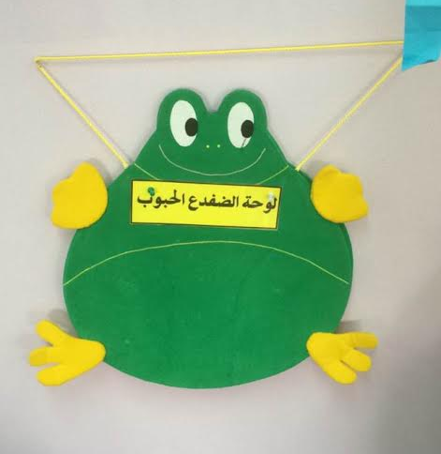
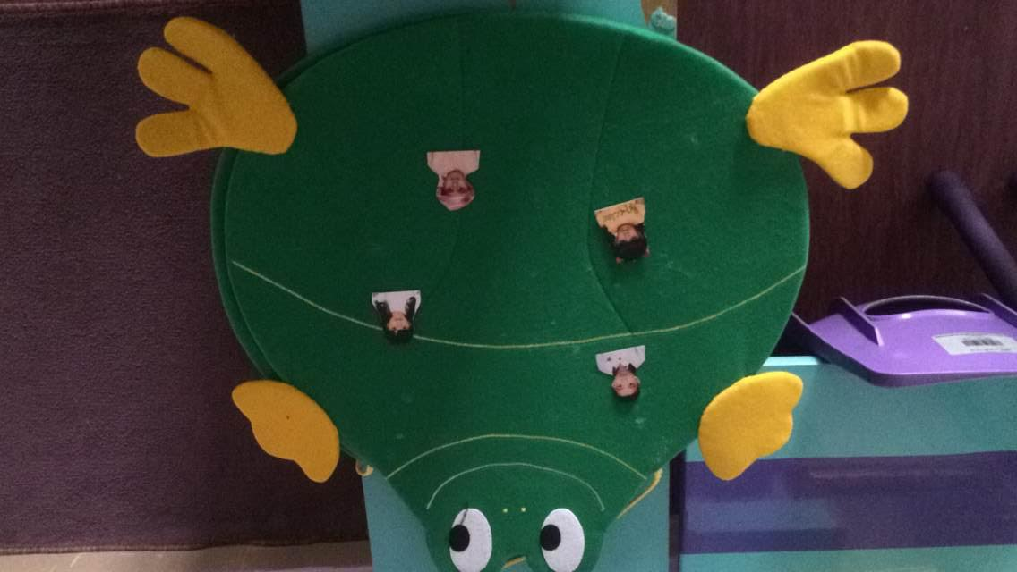

2. Consequences:
the child who bother other children or make noise in the class, the teacher let him sits beside her in the circle time, to focus on her explanation for the class and to help him and other students to be concentrated in the lesson. this way is beneficial for the naughty child to not be busy with the things around him. In another class, the teacher let her naughty child sits alone in another corner to not confuse her and the other students, so she knows how to explain the lesson. According to Skinner, he said that teachers could profit from knowing that reinforcement is effective in helping to elicit changes in behavior. Using this way will result positive results to children to reduce from their misbehavior. I think that the way my TP teacher used with the naughty child is better than the other teacher way, because it is good for all of them even the naughty child and it will give him importance by involving with the class. The way that the other teacher used is unuseful for the naughty child because sitting alone in another corner will make him be busy with the stuff of the corner, so he might make more noise in the class.

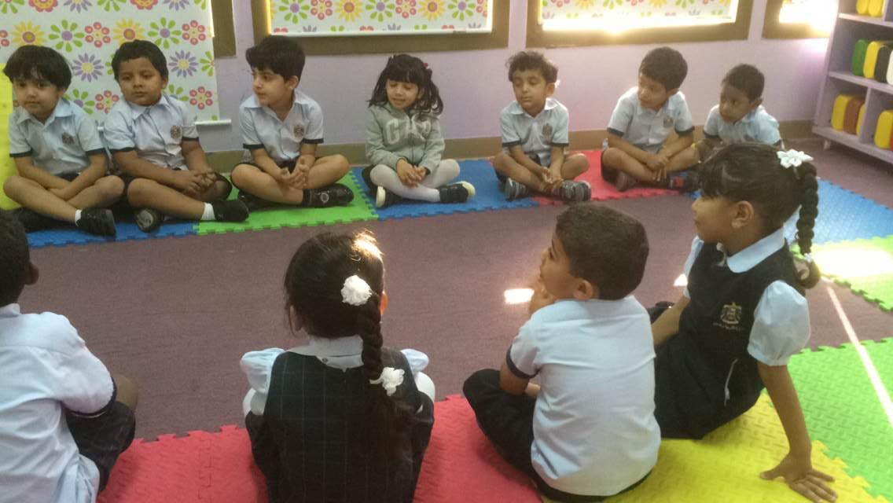

3. Setting Clear Guidelines:
Setting clear classroom rules is important for children to understand the discipline. She used photos to support their understanding. Glasser believed that it is important for the teacher to realize what could motivate students behaviorally and influence the overall classroom environment. Another teacher in the KG uses rules without adding images. This way is unuseful for children at four and five years old. My teacher used a better way than the other teacher. It is a positive way that she used clear rules with photos to assist children to apply the rules in reality.

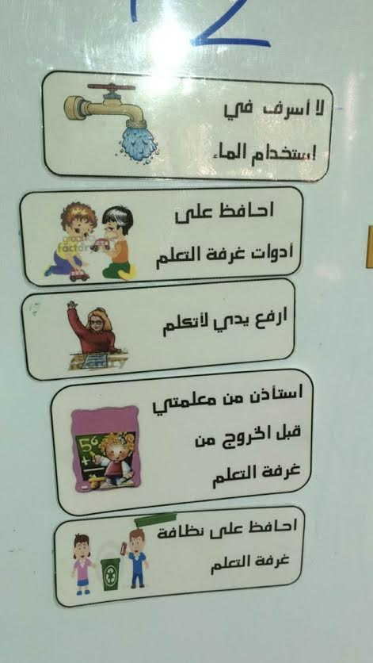

4. Transitions:
the teacher lets her students stand in two lines while moving from a place to another. When she says 'hurry up' everyone runs to the door and stand in two lines. The boys stand in a line and the girls stand in a line. She uses the word "Hurry up" to make them understand that its the time to move and stand in two lines. According to Piaget's gross motor skills, the way that the teacher is using is good to improve the children movement by motivating them to stand and run in front of the door. In my opinion, it's an effective way for children to assist them move and be organized. The other teacher in the other section using a different way to let the children move. She sings them a song about standing in lines so they run and stand in two lines. Both of the ways are beneficial and also they are more ways that encourage children to move.

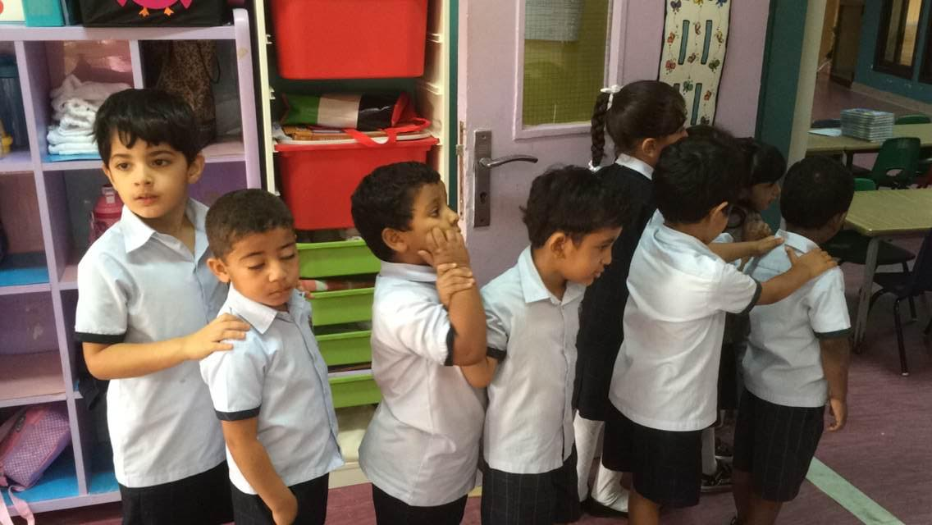

5. Attention:
When children make noise the teacher use a very useful
method to let them pay attention to her. She turns off the lights so they know that they have to pay attention to her. From the beginning of the year, she used this way so children got used to this way with the time. According to the theories of cognitive development stages from many theorists. Using this way every day improve their understanding in paying attention to the teacher. I liked this way because using it is useful to make children pay attention to the lesson and respect the teacher. The other teacher of the other section using a different way. She rings the bell to make them pay attention to her.

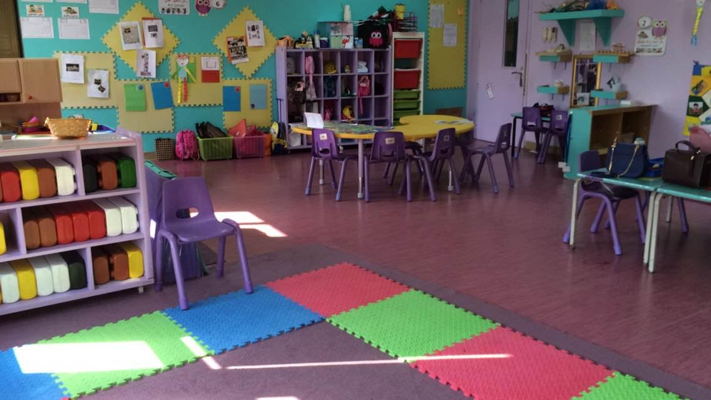

Conclusion:
At the end. I think that a successful teacher who use these strategies in a beneficial way for children to help them understand their lessons and have an enjoyable time.

References:

Websites:

1. R. Kratochwill, T. (2015). Classroom Management. Retrieved from http://www.apa.org/education/k12/classroom-mgmt.aspx

2. Allred, C. (n.d.). Seven Strategies for Building Positive Classrooms. Retrieved from http://www.ascd.org/publications/educational-leadership/sept08/vol66/num01/Seven-Strategies-for-Building-Positive-Classrooms.aspx

Books:

3. Piaget, J. (1969). The Psychology of the Child (H. Weaver, Trans.). New York: Basic Books.

4. Heriza, C. (1991). Motor Development: Traditional and contemporary Theories. In Motor Development.

